CHARLES DARWIN UNIVERSITY · PRT661 DATA SCIENCE PRACTICE

Deep Learning-Based Detection of Defective Photovoltaic Cells from Electroluminescence Images

Unit | PRT661 – Data Science Practice
Assessment use | Assessment 4 - Group Project Report
Group members | [INSERT 3–5 TEAM MEMBER NAMES]
Student IDs | [INSERT STUDENT IDS]
Lecturer / tutor | [INSERT NAME]
GitHub repository | [INSERT CLICKABLE REPOSITORY URL]
Project workspace | [INSERT GITHUB PROJECTS / JIRA / TRELLO URL]
Submission date | [INSERT DATE]
Word count | [UPDATE AFTER TEAM REVIEW]

Table of contents
Table of contents 2
List of figures 5
List of tables 5
Executive summary 6
1. Introduction 7
1.1 Industry and technical context 7
1.2 Problem statement and research question 7
1.3 Aim, objectives and success criteria 7
1.4 Scope and exclusions 8
2. Background and related work 9
2.1 Deep learning for visual inspection 9
2.2 Residual and efficient transfer learning 9
2.3 Augmentation, robustness and domain shift 10
2.4 Interpretability, calibration and uncertainty 10
3. Project evolution, governance and implementation status 11
3.1 Changes from the proposal 11
3.2 Evidence structure and reproducibility 12
3.3 Progress evaluation 12
4. Data acquisition, understanding and governance 12
4.1 Source and target construction 12
4.2 Data audit 14
4.3 Split strategy 14
4.4 Duplicate and similarity audit 15
4.5 Licensing, privacy and security 16
5. System design and methodology 16
5.1 End-to-end architecture 16
5.2 Preprocessing and augmentation 17
5.3 Class-imbalance handling 17
5.4 Traditional and custom baselines 18
5.5 ResNet18 and EfficientNet-B0 18
5.6 Evaluation metrics 19
5.7 Statistical and diagnostic analysis 19
6. Evidence and responsible prediction interface 19
6.1 Evidence dashboard and intended users 19
6.2 Prediction contract and safeguards 20
6.3 Verification and acceptance checks 20
7. Results 21
7.1 Model comparison 21
7.2 Confusion matrix and discrimination 22
7.3 Uncertainty and paired comparisons 24
7.4 Error structure 25
7.5 Explainability and feature space 26
7.6 Calibration 28
7.7 Controlled robustness 29
7.8 Cell-technology subgroup analysis 30
7.9 Computational efficiency 31
8. Discussion 32
8.1 Answer to the research question 32
8.2 Operational meaning of errors 32
8.3 Strengths of the evidence 33
8.4 Relationship to prior evidence 33
8.5 Data-intuition value 33
9. Ethics, privacy, security and risk management 33
9.1 Ethical use and communication 33
9.2 Privacy and confidentiality 34
9.3 Security and integrity 34
9.4 Risk register 34
9.5 Contingency planning 35
10. Limitations and future work 35
10.1 Limitations 35
10.2 Prioritised future work 36
10.3 Deployment readiness gates 36
11. Technical assurance, demonstration and handover 36
11.1 Requirements traceability 36
11.2 Verification and test strategy 37
11.3 Demonstration design 37
11.4 Reproducible handover 37
11.5 Monitoring and change control 38
11.6 Sustainability and resource proportionality 38
11.7 Data-management lifecycle 38
11.8 Maintainability and code quality 38
11.9 Human factors and stakeholder evaluation 39
11.10 Alternative explanations and falsification 39
12. Conclusion 40
References 41
Appendix A. Individual work and contribution pages 43
A.1 Team member 1 – [INSERT NAME AND STUDENT ID] 43
A.2 Team member 2 – [INSERT NAME AND STUDENT ID] 44
A.3 Team member 3 – [INSERT NAME AND STUDENT ID] 45
A.4 Team member 4 – [INSERT NAME AND STUDENT ID] 47
A.5 Team member 5 – [INSERT NAME AND STUDENT ID] 48

List of figures
Figure 1. Representative functional and defective ELPV cell images used to understand the controlled grayscale input domain. 9
Figure 2. Class distribution after retaining only endpoint defect probabilities; the final dataset remains imbalanced toward Functional cells. 13
Figure 3. Train, validation and test composition following joint stratification by defect class and cell technology. 14
Figure 4. Refined cross-split similarity audit distinguishing screening candidates from strictly verified high-similarity pairs. 15
Figure 5. Examples of training-only transformations used to introduce limited, label-preserving appearance variation. 17
Figure 6. Parameter-count comparison across the custom CNN, ResNet18 and EfficientNet-B0 implementations. 18
Figure 7. ResNet18 training history used with validation evidence for checkpoint selection. 19
Figure 8. Representative ResNet18 false-positive and false-negative cases selected from stored test predictions. 26
Figure 9. Grad-CAM examples across correct and incorrect ResNet18 decision categories; heatmaps indicate model sensitivity, not causal defect boundaries. 27
Figure 10. t-SNE projection of ResNet18 test embeddings, used as an exploratory view of local feature neighbourhoods. 28
Figure 11. ResNet18 reliability diagram and calibration summary on the held-out test predictions. 29
Figure 12. Change in ResNet18 performance under controlled brightness, contrast, blur, rotation and noise transformations. 30
Figure 13. Exploratory ResNet18 performance comparison for mono- and polycrystalline test cells. 31

List of tables
Table 1. Project objectives and evidence of completion 8
Table 2. Transparent change log 11
Table 3. Dataset composition 13
Table 4. Final split composition 14
Table 5. Operational workflow 16
Table 6. Final test-set model comparison 21
Table 7. ResNet18 bootstrap uncertainty 24
Table 8. Controlled perturbation results for ResNet18 29
Table 9. Updated project risk register 34

Executive summary
Photovoltaic modules are inspected throughout manufacture and service because local cell defects can reduce reliability and electrical output. Electroluminescence (EL) imaging reveals cell structure that is difficult to inspect under ordinary illumination, but manual review of many cell images is time-consuming and specialist-dependent. This project re-implemented the proposed ELPV study as a reproducible proof-of-concept pipeline covering source provenance, target construction, stratified splitting, training-only augmentation, imbalance-aware learning, a traditional logistic baseline, three neural models, validation-only threshold locking, held-out testing, uncertainty, paired tests, error analysis, explainability, calibration, robustness, subgroup analysis, similarity sensitivity, efficiency profiling, governance documentation and a responsible prediction-interface prototype.
The pinned ELPV source contains 2,624 normalised 300 x 300 grayscale images. The primary binary study retained 1,508 probability-0.0 images as Functional and 715 probability-1.0 images as Defective, while 401 intermediate-probability samples were excluded rather than forced into hard labels. The resulting 2,223 images were split into 1,556 training, 333 validation and 334 held-out test cases with joint stratification by class and cell technology. Training contained 1,056 Functional and 500 Defective cells, so the positive-class weight was 2.112. Validation and test sets were neither resampled nor randomly augmented.
Four classifiers were evaluated under the final protocol: a 1,025-parameter grayscale logistic-regression baseline, a 389,057-parameter custom CNN, ImageNet-pretrained ResNet18 and ImageNet-pretrained EfficientNet-B0. Validation-selected thresholds were 0.3300, 0.5274, 0.2609 and 0.3600 respectively and were locked before test evaluation. ResNet18 produced the strongest observed test result: accuracy 0.8353, precision 0.7190, defective-cell recall 0.8056, specificity 0.8496, F1 0.7598 and ROC-AUC 0.9182. EfficientNet-B0 was close (F1 0.7368; ROC-AUC 0.9142) and is substantially smaller. Exact McNemar tests found Custom CNN versus ResNet18 significant (p=0.0319), while ResNet18 versus EfficientNet-B0 was not significant (p=0.5114).
The additional diagnostics make the result more cautious and more useful. A 2,000-resample bootstrap placed ResNet18 F1 at 0.6923-0.8167 and ROC-AUC at 0.8807-0.9502 (95% intervals). The model made 55 errors: 34 false positives and 21 false negatives. Mean confidence was 0.9367 for correct predictions and 0.6506 for errors; 20 errors still had confidence at least 0.80. Brier score was 0.0944 and expected calibration error 0.0542. Rotation produced the largest accuracy collapse (0.5000) and F1 0.5570, while Gaussian noise reduced F1 to 0.6012. Mono- and polycrystalline F1 were 0.8041 and 0.7273. No exact cross-split duplicate was found; ten strictly verified high-similarity pairs remained, and excluding their affected test images left F1 unchanged at 0.7598.
The feedback-incorporated package also strengthens the architecture, tool-selection and governance evidence. A final evidence dashboard summarises the saved results, while an optional Gradio proof-of-concept function can return both class probabilities, a low-confidence flag and a prominent warning; it is disabled by default and is not presented as a deployed inspection service. The evidence supports useful controlled-domain triage, not autonomous defect diagnosis. External module-independent validation, broader acquisition systems and manufacturers, explicit treatment of ambiguous labels, prospective calibration and human-in-the-loop acceptance testing remain necessary before operational use.

1. Introduction

1.1 Industry and technical context
Solar photovoltaic generation depends not only on nominal module capacity but also on the continued integrity of many interconnected cells. Damage may originate during manufacture, transport, installation or service, and the visible appearance of a module under ordinary illumination may not reveal fine electrical discontinuities. Electroluminescence (EL) imaging addresses part of this inspection problem by forward-biasing the device and recording emitted near-infrared light. Regions that are electrically inactive or weak can appear darker, enabling high-resolution examination of cracks, interrupted conductors and other anomalies. Deitsch et al. (2019) describe EL as a useful non-destructive inspection modality and show why manual interpretation becomes expensive and knowledge-intensive at scale. The present project does not attempt to estimate electrical loss or identify a specific physical defect. It addresses the narrower and defensible question of whether a cell image can be assigned a functional or defective label.
Automation is attractive because a consistent classifier can triage large image volumes, present ranked cases for review and make evaluation repeatable. It is also risky. A model trained on a small public benchmark may learn acquisition-specific structure, cell-type texture, framing or annotation practice rather than a generally transferable defect concept. A false negative is operationally important because the system has labelled a defective cell as functional, while a false positive may increase unnecessary manual inspection. These error costs are not interchangeable. Consequently, a credible data-science study needs more than accuracy. It must define the target, protect the held-out test set, report sensitivity and specificity, quantify uncertainty, examine confidence, explore subgroups, test plausible image degradations, identify leakage risks and state where evidence ends. Those requirements shaped the implemented workflow.

1.2 Problem statement and research question
The practical problem is the efficient prioritization of individual photovoltaic-cell EL images for specialist review. The analytical problem is binary supervised classification under class imbalance, uncertain source annotations and potential correlation between similar cells. The research question was: can deep-learning image classifiers distinguish high-confidence functional cells from high-confidence defective cells in the ELPV dataset, and how dependable are their predictions when examined beyond a single aggregate score? The qualification ‘high-confidence’ is central. ELPV supplies probabilities rather than a universally agreed hard diagnosis, so the implementation retained only the endpoint annotations 0.0 and 1.0. This choice creates a clearer target but also narrows the population about which the study can speak.

1.3 Aim, objectives and success criteria
The aim was to design a reproducible proof-of-concept classification and evidence system, not a certified inspection service. Objectives were to audit and document the dataset; justify the end-to-end architecture and tool choices; construct leakage-conscious splits; apply consistent preprocessing; address imbalance only in training; implement a traditional logistic baseline, a compact custom CNN and two transfer-learning models; lock thresholds on validation data; evaluate the untouched test set with complementary metrics and paired tests; inspect errors, calibration, learned representations and Grad-CAM; test controlled robustness and mono/poly subgroups; quantify similarity sensitivity and computational cost; and package versioned evidence for responsible communication.
Table 1. Project objectives and evidence of completion
Objective | Implementation evidence | Status
Acquire, audit and govern data | Pinned source, five-V summary, label/image audits, provenance and manifest | Complete
Prevent avoidable leakage | Frozen splits, MD5/perceptual audit, strict verification and sensitivity analysis | Complete
Compare justified classifiers | Traditional logistic baseline, custom CNN, ResNet18 and EfficientNet-B0 | Complete
Evaluate responsibly | Validation-locked thresholds, held-out metrics, bootstrap intervals and McNemar tests | Complete
Interpret and stress-test | Grad-CAM, embeddings, calibration, corruption, subgroup and confidence analysis | Complete
Communicate with safeguards | Evidence dashboard plus optional probability-and-warning prototype | Complete

A model was not considered successful merely because its accuracy exceeded the majority-class baseline. The principal operating model needed a defensible balance between defective-cell recall and precision, a useful ROC–AUC, transparent error counts and reasonable behaviour under controlled variation. The interface also needed to prevent misinterpretation. It therefore labels the project as a proof of concept, retains the validation-locked threshold as the reported setting, distinguishes threshold simulation from retuning, and states that subgroup differences are exploratory. These acceptance criteria connect technical design to the unit’s requirements for viable implementation, critical evaluation, ethics and communication.

1.4 Scope and exclusions
The unit of analysis is a pre-extracted, normalised grayscale image of one photovoltaic cell. The primary target has two classes: Functional for source defect probability 0.0 and Defective for probability 1.0; probabilities 0.3333 and 0.6667 are excluded from the primary classifier. The study compares one traditional pixel baseline and three neural image classifiers and uses mono/poly labels for stratification and exploratory subgroup analysis. It does not segment full module photographs, locate physical crack boundaries, estimate power loss, identify a specific defect mechanism, or claim transfer to other EL acquisition systems. The optional prediction prototype is a research demonstrator only.
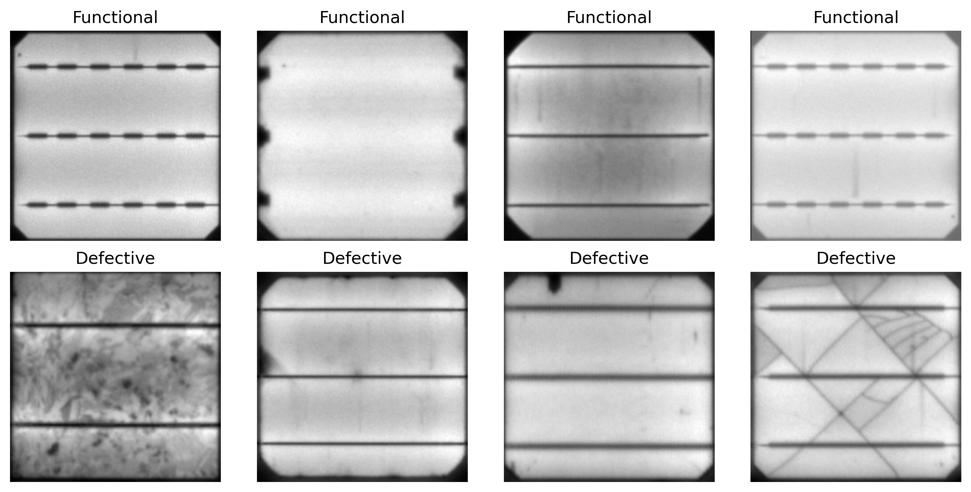
Figure 1. Representative functional and defective ELPV cell images used to understand the controlled grayscale input domain.

2. Background and related work

2.1 Deep learning for visual inspection
Convolutional neural networks learn spatial feature hierarchies directly from pixel arrays. Earlier layers commonly respond to edges and local texture, while deeper layers combine those responses into representations useful for a prediction task. The general ability of deep models to learn multiple levels of abstraction is reviewed by LeCun, Bengio and Hinton (2015), and the large-scale ImageNet result of Krizhevsky, Sutskever and Hinton (2012) helped establish GPU-trained convolutional networks as practical visual classifiers. For EL inspection, this capability is relevant because defects may be expressed as local dark regions, interrupted structures or texture deviations rather than a small set of easily specified rules. Nevertheless, feature learning does not guarantee that the features are physically causal, and this report avoids treating attention maps as defect measurements.
Deitsch et al. (2019) evaluated support-vector and convolutional approaches for automatic analysis of EL cell imagery and reported the value of learned image representations for defect likelihood. Their study also explains the operational motivation: manual EL review is costly and requires expertise, while high spatial resolution makes subtle abnormalities accessible to computation. Akram et al. (2019) subsequently demonstrated a lightweight CNN approach and examined augmentation for EL defect detection. These studies establish a technical precedent but do not remove the need to audit a new implementation. Dataset filtering, split construction, label definition, threshold selection and evaluation protocol can materially change the result even when the source images are nominally the same.

2.2 Residual and efficient transfer learning
Transfer learning begins with parameters learned on a large source task and adapts them to a smaller target dataset. The approach is attractive here because 2,223 binary examples are modest by modern deep-learning standards. ResNet introduced residual connections that learn a residual mapping around identity shortcuts, making deeper networks easier to optimise (He et al., 2016). ResNet18 is relatively compact within that family but still provides a mature hierarchy of pretrained visual filters. In this implementation, the single EL channel was replicated to three channels to match ImageNet input conventions. The classification head was warmed up before later residual features were fine-tuned, reducing the risk of immediately disrupting useful pretrained weights.
EfficientNet takes a different approach to capacity, balancing network depth, width and input resolution through compound scaling (Tan & Le, 2019). EfficientNet-B0 provides a useful comparison because it uses fewer parameters than ResNet18 while retaining a sophisticated pretrained backbone. It is not assumed to be universally superior. The project evaluates the models under one controlled protocol and separates ranking ability from performance at a chosen decision point. That distinction proved important: EfficientNet-B0 obtained the highest test ROC–AUC, whereas ResNet18 produced the highest accuracy and F1 at its validation-locked threshold. Selecting a model by one headline number would have obscured this trade-off.

2.3 Augmentation, robustness and domain shift
Image augmentation can increase the variety presented during training without altering the held-out data. Shorten and Khoshgoftaar (2019) describe augmentation as a data-space strategy for reducing overfitting when labelled image collections are limited. The present transforms—horizontal and vertical flips, small rotations and limited crop variation—were chosen because they plausibly preserve a cell’s defect class while changing appearance. Even reasonable augmentation can create unrealistic examples or leak into evaluation if applied before splitting. The implementation therefore created train, validation and test indices first and used stochastic transforms only when loading training images.
Clean-test performance does not describe behaviour under acquisition change. Common corruptions such as noise, blur, brightness variation and geometric perturbation can expose brittle visual representations; Hendrycks and Dietterich (2019) formalised this broader robustness concern. The project applied controlled transformations to the same test images to estimate sensitivity, not to simulate an independent field cohort. The distinction matters. A corruption test can show that output changes when pixels are altered, but it cannot measure variation caused by another camera, module manufacturer, segmentation pipeline, maintenance context or labelling process. The report accordingly calls these experiments-controlled robustness tests and reserves ‘external validation’ for genuinely independent data.

2.4 Interpretability, calibration and uncertainty
Grad-CAM uses gradients entering a selected convolutional layer to produce a coarse class-discriminative heatmap (Selvaraju et al., 2017). It is valuable for inspecting whether a network response is concentrated on a plausible cell region and for comparing true and false decisions. It is not a segmentation method and does not demonstrate that a highlighted pixel corresponds to a physical crack. This report uses the maps as model-attention evidence only. PCA and t-SNE provide complementary views of learned feature space. PCA gives a linear projection with explained variance, while t-SNE preserves local neighbourhood structure for visualisation (van der Maaten & Hinton, 2008). Neither plot proves class separability in the population.
Probability quality is distinct from class accuracy. A system can rank defective cells well and still attach probabilities that do not match observed correctness. Guo et al. (2017) show that modern neural networks can be miscalibrated, motivating reliability diagrams and expected calibration error. This project reports Brier score, expected calibration error and confidence distributions, then counts high-confidence errors. Bootstrap intervals quantify sampling uncertainty in metrics on the 334-image test set. Exact McNemar tests compare paired correctness because every model predicts the same cases. These methods do not eliminate uncertainty, but they make claims more proportionate to the evidence.

3. Project evolution, governance and implementation status

3.1 Overall Project Architecture
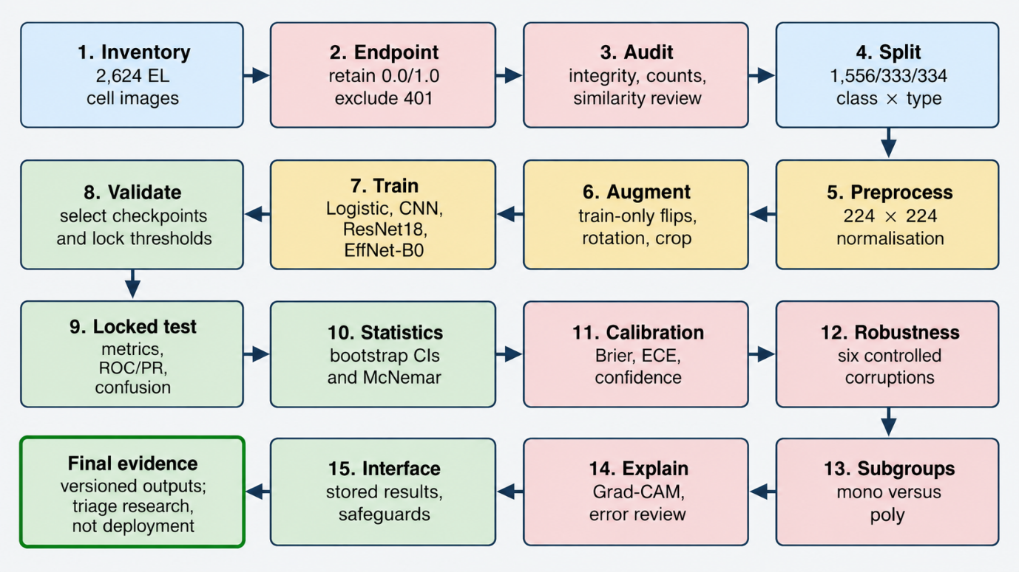
Figure 2. Class distribution after retaining only endpoint defect probabilities; the final dataset remains imbalanced toward Functional cells.

The implementation expands the original lightweight-CNN plan in direct response to feedback. A traditional logistic-regression baseline on downsampled grayscale pixels now establishes a non-deep-learning reference; the custom CNN retains a compact task-specific model; ResNet18 and EfficientNet-B0 test transfer learning. The workflow now documents architectural alternatives and production requirements, uses validation-only operating thresholds, records the five data-science Vs, adds exact and perceptual leakage auditing with strict verification, and includes calibration, robustness, subgroup, efficiency, bootstrap and paired McNemar evidence. These additions strengthen the validity and explainability of the answer without changing the original binary research question.
Table 2. Transparent change log
Area | Proposal state | Feedback-incorporated implementation | Justification
Models | Lightweight CNN | Logistic baseline + CNN + ResNet18 + EfficientNet-B0 | Adds traditional and transfer-learning comparators
Architecture/tools | High-level workflow | Pinned source -> audit -> frozen splits -> modelling -> evidence package; alternatives documented | Makes design and tool selection explicit
Threshold | Default classification | Validation-selected and locked per model | Protects final test from tuning
Leakage | No path overlap | MD5, perceptual screening, strict verification and sensitivity analysis | Repetitive EL structure needs stronger checks
Evaluation | Core metrics | CIs, McNemar, calibration, robustness, subgroups, confidence and efficiency | Supports critical interpretation
Interface/governance | Visualisations | Evidence dashboard, optional guarded prototype, five Vs and risk artefacts | Addresses communication and governance feedback

Model-selection language is deliberately evidence-bounded. ResNet18 has the highest observed F1 and ROC-AUC in the locked test comparison, but the exact paired accuracy comparison against EfficientNet-B0 is not significant (p=0.5114). EfficientNet-B0 therefore remains a credible, more compact alternative rather than an inferior model by statistical proof. The logistic baseline and custom CNN show the incremental value of learned image representations. Similarity findings are also retained transparently and followed by a direct sensitivity analysis rather than being omitted from the report.

3.2 Evidence structure and reproducibility
The final package separates notebook logic, figures, tables, model artefacts and documentation. Machine-readable CSV files hold frozen splits, model predictions, thresholds, histories, bootstrap intervals, calibration bins, robustness conditions, subgroup metrics, similarity audits, paired tests and efficiency records. PyTorch state dictionaries preserve the three neural networks and a joblib artefact stores the traditional logistic baseline. Environment, provenance, architecture, five-V, risk and manifest documents make major claims traceable to executable or machine-readable evidence rather than narrative alone.
Reproducibility remains platform-bounded. Seeds and split files are recorded, but exact floating-point reproduction is not guaranteed across software versions or devices. The supplied environment record identifies the CUDA/PyTorch context without claiming a specific GPU model; consequently, latency and throughput values should be treated as runtime-specific measurements. A reproducible rerun should preserve the pinned dataset revision, split CSVs, package versions, seeds, preprocessing configuration and model/checkpoint hashes.

3.3 Progress evaluation
The feedback-incorporated analytical implementation is complete: source acquisition and audit, binary target construction, splitting, four-model comparison, threshold locking, final test evaluation, uncertainty, errors, explainability, calibration, robustness, subgroup analysis, similarity sensitivity, efficiency and responsible interface logic are all represented in the output package. Remaining items are team-specific evidence that cannot be fabricated from the notebook: authentic names and IDs, Jira/GitHub links, contribution records, reviews and required screenshots. Production deployment is also outside the implemented scope.

4. Data acquisition, understanding and governance

4.1 Source and target construction
ELPV is a public benchmark derived from electroluminescence images of photovoltaic modules and distributed with cell-level images, defect probabilities and cell-technology labels. The collection contains 2,624 normalised 300 × 300, 8-bit grayscale images from 44 modules. The endpoint probabilities provide a convenient high-confidence binary target, but the underlying values reflect annotation evidence rather than direct continuous electrical-loss measurement. The project mapped 0.0 to Functional and 1.0 to Defective. It excluded 401 samples carrying 0.3333 or 0.6667 from the primary dataset instead of rounding them. This is a transparent abstention from ambiguous supervision, not evidence that those cells are unimportant.
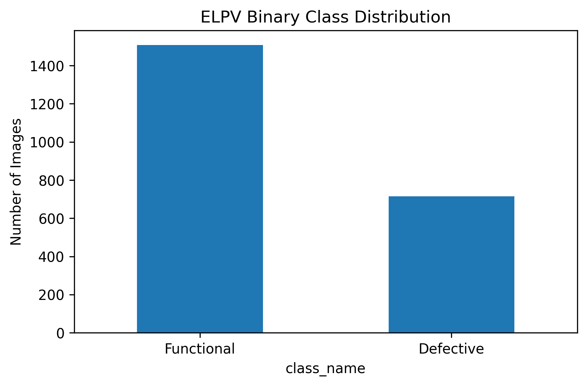
Figure 3. Class distribution after retaining only endpoint defect probabilities; the final dataset remains imbalanced toward Functional cells.
Table 3. Dataset composition
Label group | Images | Use in primary binary study
Functional probability 0.0 | 1,508 | Class 0 – Functional
Defective probability 1.0 | 715 | Class 1 – Defective
Intermediate probabilities | 401 | Excluded from primary classifier
Original total | 2,624 | Source collection
Final binary total | 2,223 | Train / validation / test population

The decision to exclude ambiguous labels trades breadth for label clarity. It should make the learned boundary easier to interpret because positive and negative endpoints are less contestable, but it also creates spectrum bias: the model is evaluated on clearer cases and may encounter substantially harder decisions if applied to intermediate cells. A deployment-oriented system would need an explicit approach to uncertainty, perhaps ordinal modelling, probabilistic regression, label-distribution learning or an abstention class. The binary results in this report therefore apply to the retained endpoints, not the complete ELPV distribution.

4.2 Data audit
The audit verified label loading, file existence, image dimensions, class counts, cell-type counts and the absence of immediate path overlap. Images were examined visually to understand recurring busbars, texture, intensity variation and defect appearance. This inspection informed physically cautious augmentation choices. The source records were preserved, and derived split tables identify the images assigned to each partition. No corrupted image was reported in the final implementation summary. Data provenance is documented so a future reviewer can distinguish public inputs, generated predictions and derived plots.

4.3 Split strategy
Using random seed 42, the implementation allocated 1,556 images to training, 333 to validation and 334 to final testing. Joint stratification by defect class and cell technology maintained both target balance and mono/poly representation as far as possible. The training set contained 1,056 Functional and 500 Defective cells; validation contained 226 and 107; test contained 226 and 108. Validation supported checkpoint selection and operating-threshold choice. The test set remained unavailable for tuning and was evaluated only after model and threshold decisions were fixed.
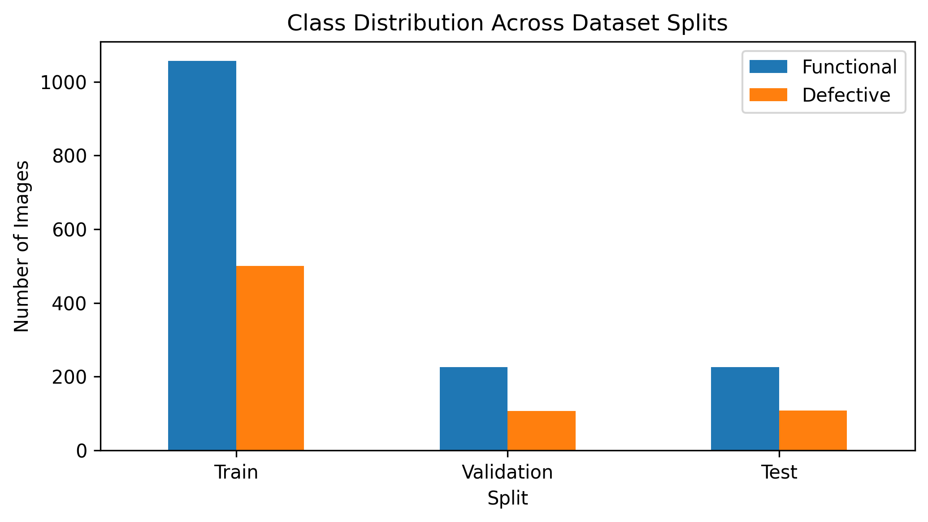
Figure 4. Train, validation and test composition following joint stratification by defect class and cell technology.
Table 4. Final split composition
Partition | Functional | Defective | Total | Purpose
Training | 1,056 | 500 | 1,556 | Parameter learning and training-only augmentation
Validation | 226 | 107 | 333 | Checkpoint and threshold selection
Test | 226 | 108 | 334 | One final unbiased internal evaluation

A limitation remains because the available implementation metadata did not guarantee module-level grouping. Images extracted from the same module may share acquisition or manufacturing characteristics. Joint class-and-technology stratification is better than an unconstrained random split, but it does not substitute for group-aware splitting by module identifier. The similarity audit reduces concern about direct or near duplication, while the unchanged sensitivity result provides additional reassurance, yet neither establishes full module independence. This issue is carried into the limitations and future-validation plan.

4.4 Duplicate and similarity audit
Exact MD5 comparison found no identical image across partitions. Because EL cells contain repetitive grid and busbar structure, perceptual screening initially produced many candidates. A stricter second-stage verification using pHash and additional image-similarity checks reduced these to ten cross-split high-similarity pairs: five Train-Validation, four Train-Test and one Validation-Test pair. These are recorded explicitly rather than treated as proof of leakage or ignored. The audit therefore distinguishes broad screening sensitivity from a smaller set of strongly similar cases.
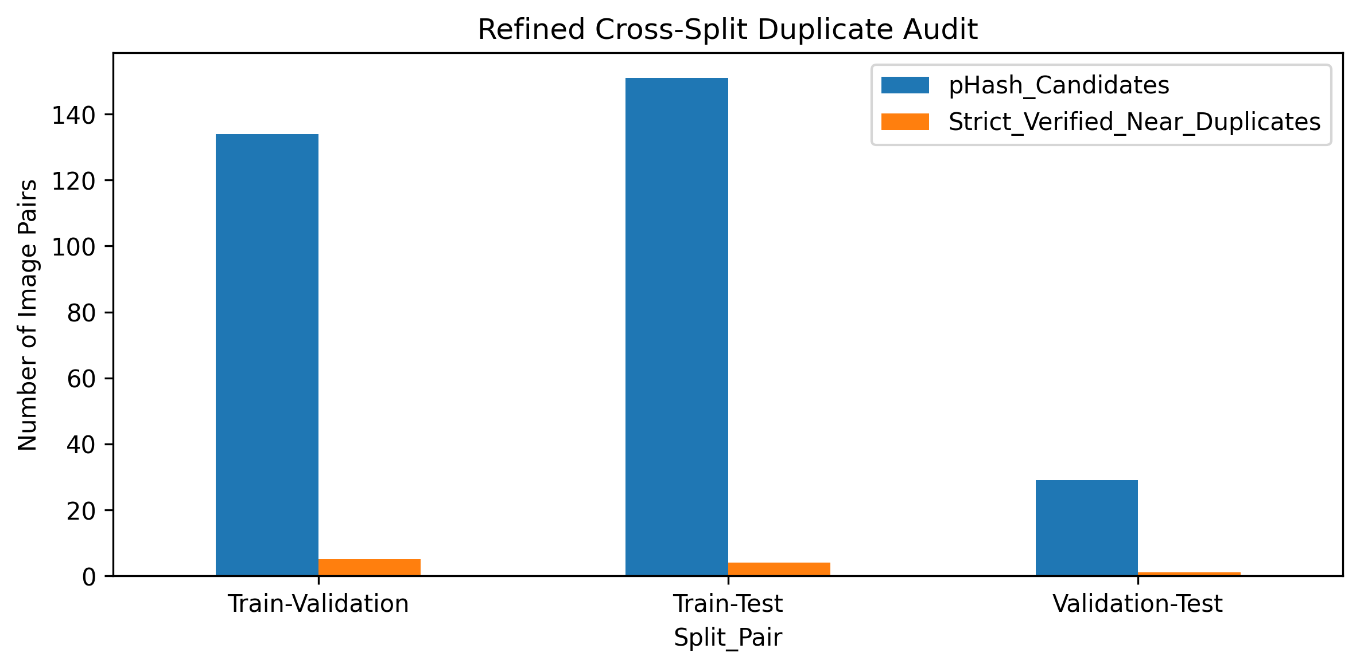
Figure 5. Refined cross-split similarity audit distinguishing screening candidates from strictly verified high-similarity pairs.
The high-similarity sensitivity analysis excluded the affected test images without changing model parameters or the locked ResNet18 threshold. The test population fell from 334 to 329; accuracy changed from 0.8353 to 0.8328, F1 remained 0.7598 and ROC-AUC changed only from 0.9182 to 0.9178. This result suggests that the strictly verified similarities did not explain the primary ResNet18 performance, while still leaving module-level or other unobserved dependence as a limitation that requires external group-aware validation.

4.5 Licensing, privacy and security
The images contain photovoltaic cells rather than identifiable people, so direct personal-privacy risk is minimal. Data governance still matters. The dataset’s attribution and non-commercial/share-alike terms should be checked against any intended use, and the source citation must travel with redistributed images. The repository should avoid embedding absolute local paths, credentials or private service tokens. Model files and result tables need checksums and controlled release because an accidental mismatch between code, threshold and checkpoint could silently change decisions. Backups, versioned manifests and role-appropriate write permissions address integrity and availability even when confidentiality risk is low.

5. System design and methodology

5.1 End-to-end architecture
The implemented architecture is a versioned offline analytical pipeline. A pinned ELPV source enters integrity and count checks, immutable raw records and high-confidence binary filtering; frozen stratified train/validation/test CSVs then feed train-only preprocessing and augmentation. Modelling compares a grayscale logistic baseline, custom CNN, ResNet18 and EfficientNet-B0. Validation controls checkpoint and threshold decisions; the locked test feeds uncertainty, paired tests, errors, Grad-CAM, calibration, representation, robustness, subgroup, similarity and efficiency analyses. Versioned CSV, PNG, checkpoint/joblib, environment and manifest artefacts then support reporting and an optional probability-and-warning prototype. A production system would additionally require authenticated ingestion, validation, encryption, a model registry, audit logging, drift monitoring, retention controls and expert feedback.
Table 5. Operational workflow
Stage | Input | Operation | Persistent output
1. Acquire/audit | Pinned ELPV images and labels | Verify source, files, counts, 5Vs and provenance | Audit/provenance tables and sample figures
2. Split | 2,223 endpoint-labelled records | Jointly stratify class and cell type | Frozen train/validation/test CSVs
3. Train | Training partition only | Fit logistic baseline and three neural models; augment/weight only training | joblib/checkpoints and histories
4. Select | Validation probabilities | Select checkpoints and per-model thresholds | Locked-threshold records
5. Test | Untouched held-out test | Run final four-model comparison | Predictions, metrics and paired evidence
6. Diagnose | Locked predictions/features | Errors, CIs, Grad-CAM, calibration, robustness, subgroups, similarity | Figures and machine-readable tables
7. Communicate | Verified artefacts | Dashboard, guarded prototype contract and reporting | PNG/CSV/DOCX plus governance/manifest files

5.2 Preprocessing and augmentation
All networks received 224 × 224 inputs. The custom CNN used one grayscale channel normalised with training-derived mean 0.5935 and standard deviation 0.1613. The transfer models received the grayscale channel replicated three times and standard ImageNet normalisation to remain compatible with their pretrained filters. Training transforms included horizontal and vertical flips and small rotations; transfer-model training also used limited resized cropping. Evaluation transforms were deterministic. This separation ensures that validation and test probabilities refer to stable inputs and that synthetic variants of a test image do not enter training.
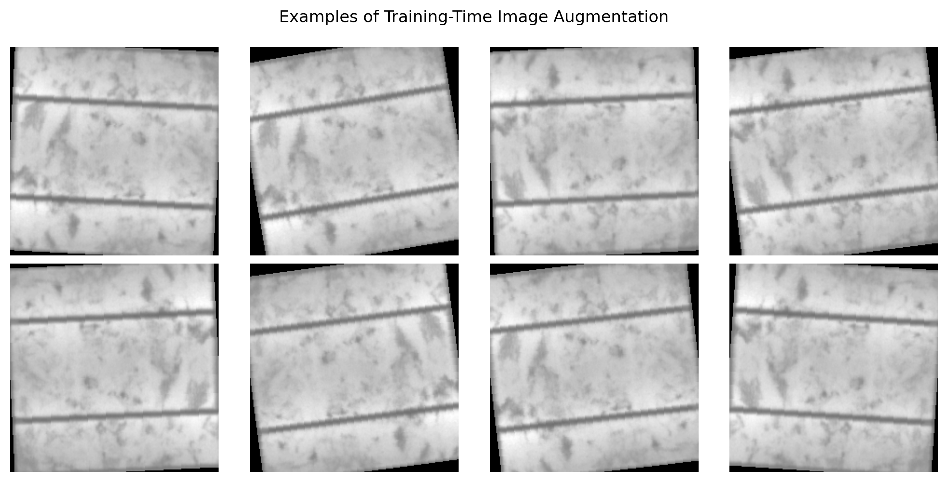
Figure 6. Examples of training-only transformations used to introduce limited, label-preserving appearance variation.
Augmentation was intentionally conservative. A photovoltaic cell can be imaged at different orientation, and modest crops or rotations can increase tolerance to framing. More aggressive elastic deformation, arbitrary erasing or large photometric shifts could alter the physical structures that indicate defects. The later corruption experiment was not fed back into model tuning; it was used to reveal sensitivity after the main evaluation. This distinction avoids selecting a model specifically to a small hand-chosen set of test corruptions.

5.3 Class-imbalance handling
The training Functional-to-Defective ratio was 2.112:1. A naïve classifier could improve apparent accuracy by favouring Functional predictions, which would be unacceptable when missed defects are important. The implementation used BCEWithLogitsLoss with positive-class weight 2.1120. Weighting changes the penalty attached to defective examples during optimisation without altering the observed validation or test prevalence. No SMOTE or image synthesis was applied outside training. Precision, recall, specificity, balanced accuracy, F1, ROC–AUC and average precision were reported so the effect of imbalance remained visible.

5.4 Traditional and custom baselines
The traditional baseline uses 32 x 32 grayscale pixels flattened into a logistic-regression classifier with 1,025 parameters. It provides a transparent non-neural reference and achieved test accuracy 0.7455, defective-cell recall 0.7222, F1 0.6473 and ROC-AUC 0.7800 at validation-locked threshold 0.3300. The custom CNN uses 389,057 parameters and learned spatial features directly from the EL images; it improved to accuracy 0.7784, recall 0.7593, F1 0.6891 and ROC-AUC 0.8462 at threshold 0.5274. Together, these baselines show the gain from convolution before transfer learning is introduced.
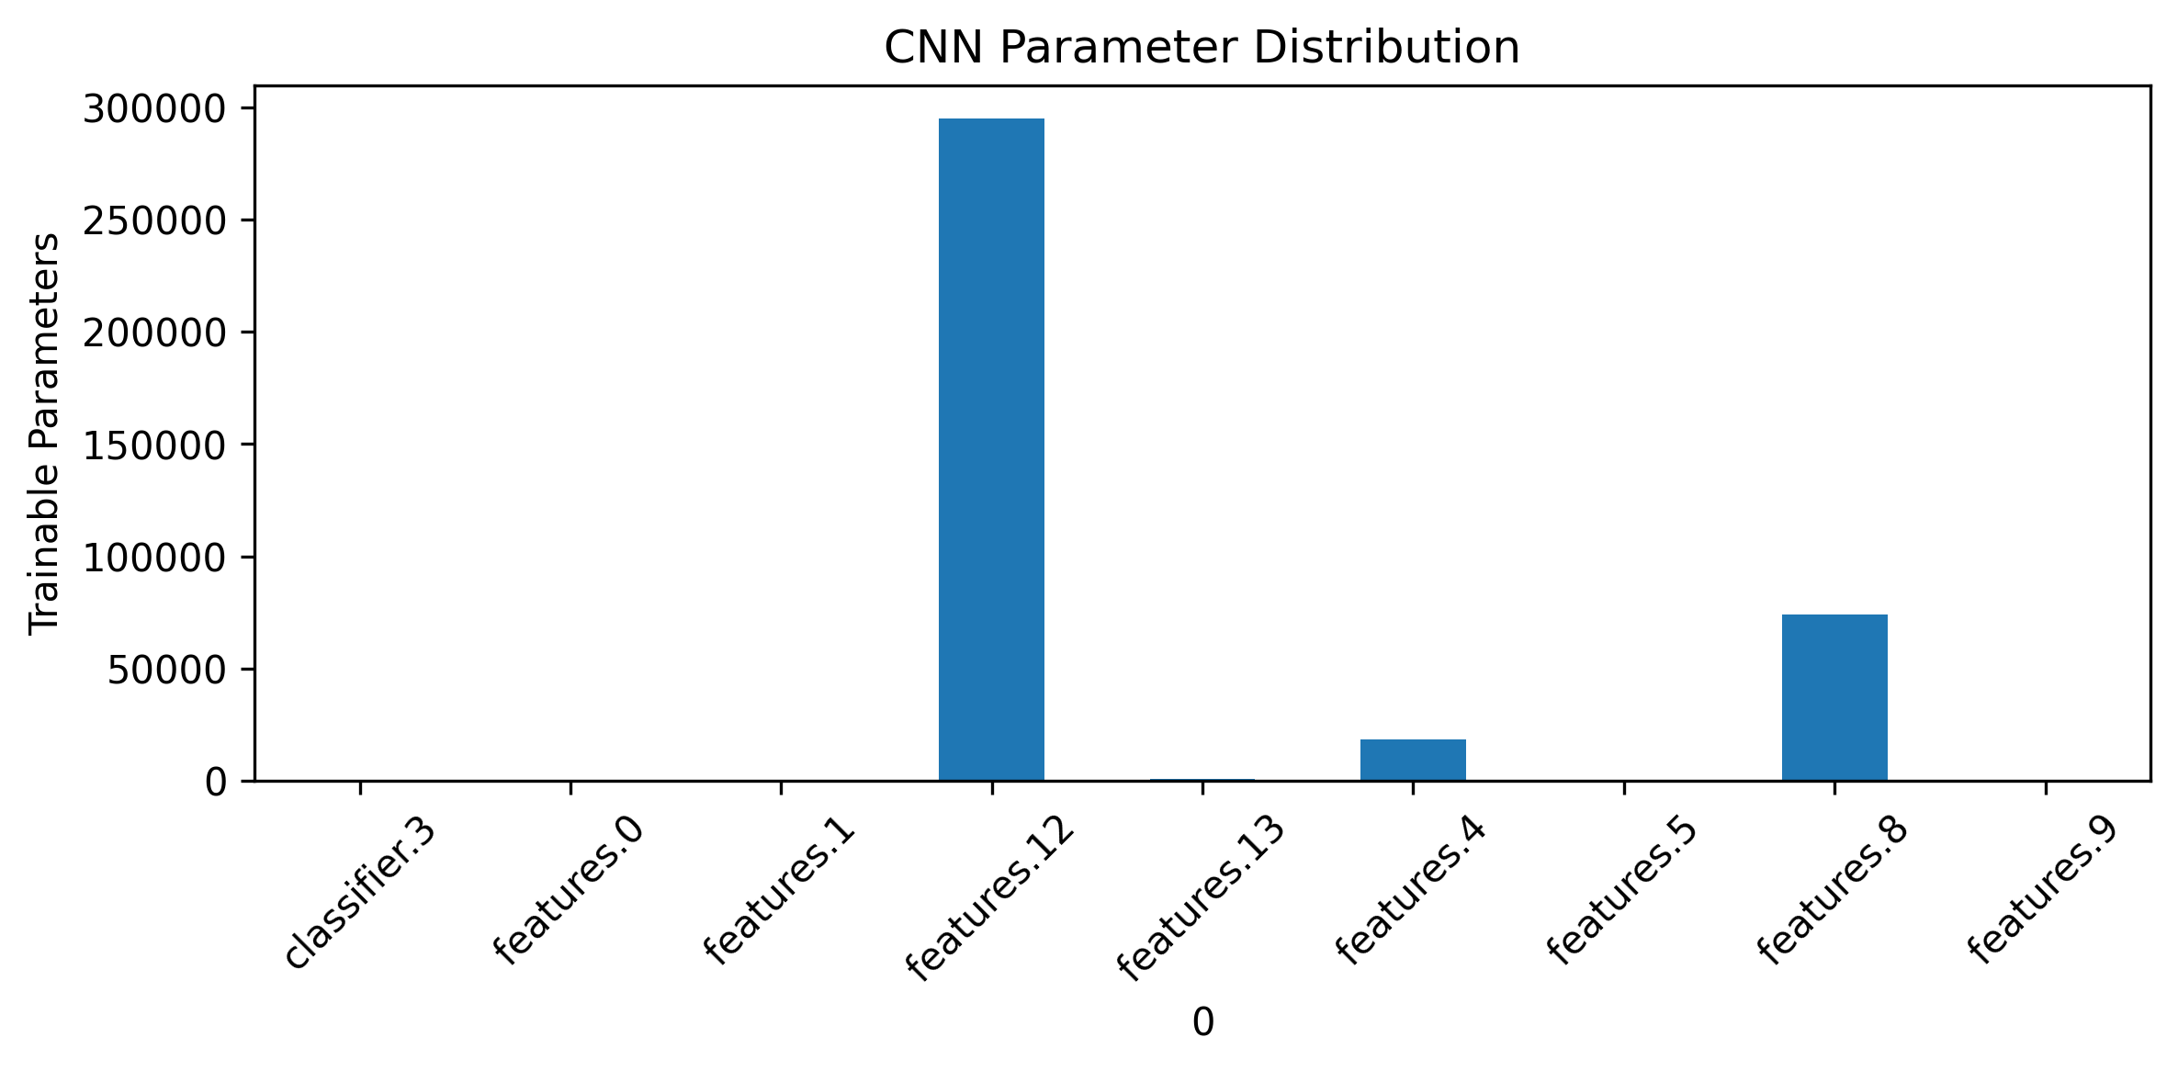
Figure 7. Trainable-parameter distribution across layers of the custom CNN baseline.

5.5 ResNet18 and EfficientNet-B0
ResNet18 used ImageNet-1K V1 weights and 11,177,025 total parameters. Training began with a classifier warm-up and then unfroze layer4 for fine-tuning. This staged approach lets a randomly initialised binary head adapt before higher-level pretrained features move. EfficientNet-B0 used ImageNet-1K V1 weights, 4,008,829 parameters and an analogous warm-up followed by fine-tuning of later feature blocks. Both heads produced one logit for defective-cell probability. The comparison therefore covered three capacity and representation regimes: small custom learning, residual transfer and efficiently scaled transfer.
Checkpoint and operating-point choices were made only from validation evidence. The locked thresholds were 0.3300 for logistic regression, 0.5274 for the custom CNN, 0.2609 for ResNet18 and 0.3600 for EfficientNet-B0. This separation is essential: the test labels are used to describe final performance, not to optimise the threshold. A different deployment cost function could justify another threshold, but it would need to be selected on new validation data rather than by searching the held-out test set.
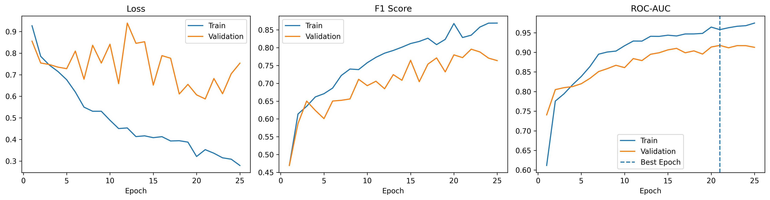
Figure 8. ResNet18 training history used with validation evidence for checkpoint selection.

5.6 Evaluation metrics
Accuracy measures the fraction of all predictions that are correct, while precision asks what proportion of predicted defects are truly labelled defective. Recall, or sensitivity, asks what proportion of labelled defective cells are found. Specificity measures the corresponding rate for Functional cells. F1 is the harmonic mean of precision and recall and is useful when neither error type should disappear behind the majority class. Balanced accuracy averages sensitivity and specificity. ROC–AUC measures ranking across all thresholds; average precision summarises the precision–recall curve and is often more informative about the positive class under imbalance. The confusion matrix preserves the concrete counts behind these rates.
No metric answers the industrial question by itself. The study treats defective-cell recall as important because a false negative can allow a problematic cell to pass an automated screen, but precision also matters because a flood of false alarms can make triage inefficient. The final operating point should eventually be chosen from quantified business costs, inspection capacity and safety requirements, not simply maximum F1. In the absence of those client-specific costs, the validation-optimised balance is a transparent research choice and threshold simulation in the interface illustrates alternatives without changing the final reported result.

5.7 Statistical and diagnostic analysis
The final ResNet18 prediction vector was resampled with replacement 2,000 times to estimate percentile confidence intervals for accuracy, precision, recall, F1, ROC–AUC and average precision. Bootstrap intervals capture variability associated with the finite test sample under an assumption that test observations are representative and sufficiently independent. Exact McNemar tests used discordant paired correctness counts to compare models on the same cases. Calibration analysis computed a Brier score and binned reliability summary. Diagnostic analysis then inspected confidence, errors shared between models, Grad-CAM, PCA/t-SNE features, controlled corruptions and mono/poly results. Together these procedures answer different questions and should not be collapsed into one claim.

6. Evidence and responsible prediction interface

6.1 Evidence dashboard and intended users
The final package communicates results through stored figures, CSV tables and a feedback-integrated evidence dashboard that summarises model comparison, uncertainty, robustness and governance status. It is intended for project reviewers and technical stakeholders who need to understand why the preferred model was selected and where it fails. In addition, the notebook contains an optional Gradio prediction prototype for a single EL cell image. The prototype is disabled by default and is not a hosted service; it simply demonstrates how the saved ResNet18 checkpoint could expose class probabilities and uncertainty-oriented warnings without changing the reported evaluation.
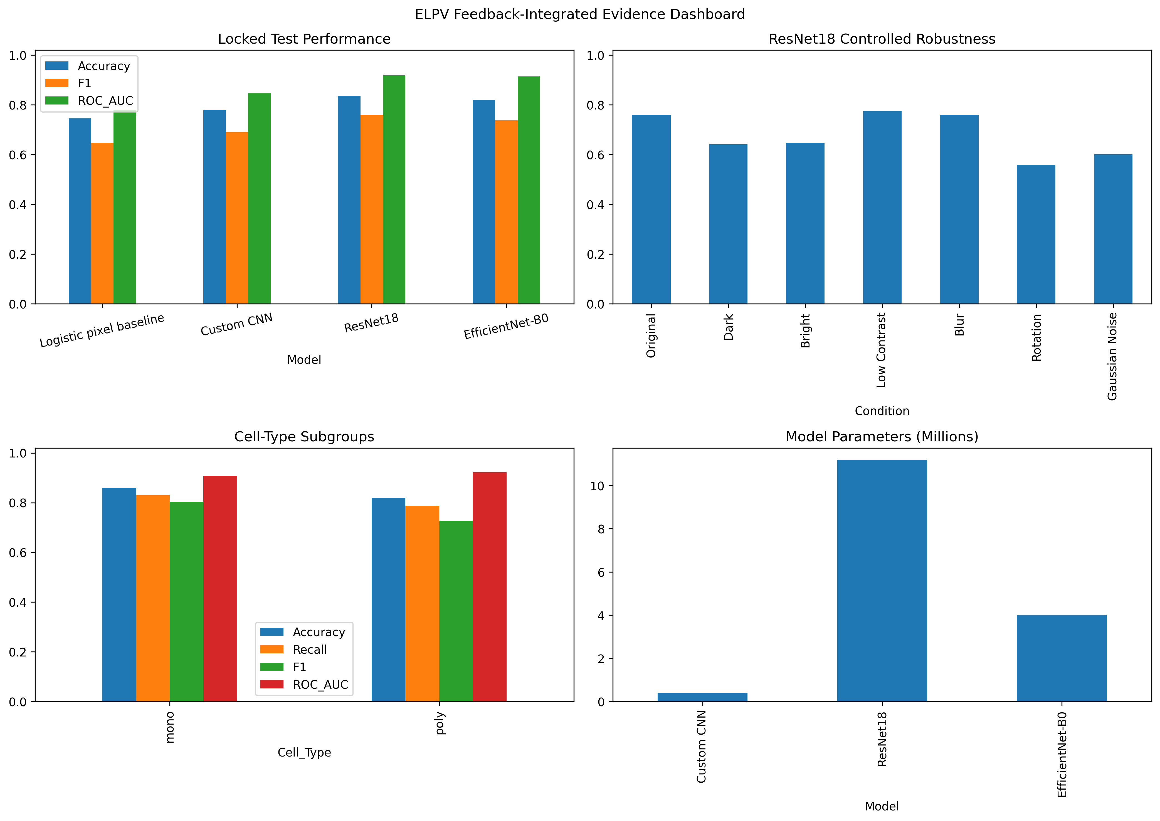
Figure 9. Feedback-integrated evidence dashboard summarising model performance, uncertainty, robustness and governance status.

6.2 Prediction contract and safeguards
The prototype prediction contract returns probabilities for Functional and Defective, the predicted class, and a low-confidence flag when maximum class probability is below 0.75. It carries a clear proof-of-concept warning and does not provide a diagnosis, maintenance action or safety decision. The reported test metrics remain tied to the validation-locked threshold and stored test predictions; interacting with a prototype must not retune those results. A production service would require input validation, quality checks, version display, out-of-distribution controls, logging, access control and a specialist-review pathway.
Safeguards are grounded in observed evidence: 401 ambiguous source labels are outside the binary target; 21 defective test cells were missed by ResNet18; 20 of 55 total errors still had confidence at least 0.80; controlled perturbations caused substantial shifts; and no independent external dataset was evaluated. Grad-CAM is labelled as model attention rather than causal defect localisation. These limitations are functional requirements for communication, because they constrain how a non-specialist should interpret the output.

6.3 Verification and acceptance checks
Acceptance checking is evidence-based rather than a claim of deployment. The saved comparison table reproduces ResNet18 accuracy 0.8353, F1 0.7598, ROC-AUC 0.9182 and threshold 0.2609; its confusion counts are 192 true negatives, 34 false positives, 21 false negatives and 87 true positives. Figure and CSV manifests are consistent with these values, and the optional prediction function is configured to load the saved model and emit probability/warning fields. These checks verify consistency of the packaged research artefacts; they do not constitute industrial validation.

7. Results

7.1 Model comparison
All four classifiers learned useful signal, but their performance forms a clear hierarchy. Logistic regression achieved accuracy 0.7455, F1 0.6473 and ROC-AUC 0.7800. The custom CNN improved to accuracy 0.7784, F1 0.6891 and ROC-AUC 0.8462. EfficientNet-B0 reached accuracy 0.8204, F1 0.7368 and ROC-AUC 0.9142. ResNet18 produced the strongest observed combination with accuracy 0.8353, precision 0.7190, defective-cell recall 0.8056, specificity 0.8496, F1 0.7598, balanced accuracy 0.8276 and ROC-AUC 0.9182. The traditional baseline therefore confirms that transfer-model performance is not merely a consequence of a trivially separable pixel target.
Table 6. Final test-set model comparison
Model | Accuracy | Precision | Recall | Specificity | F1 | ROC-AUC | Threshold
Logistic baseline | 0.7455 | 0.5865 | 0.7222 | 0.7566 | 0.6473 | 0.7800 | 0.3300
Custom CNN | 0.7784 | 0.6308 | 0.7593 | 0.7876 | 0.6891 | 0.8462 | 0.5274
ResNet18 | 0.8353 | 0.7190 | 0.8056 | 0.8496 | 0.7598 | 0.9182 | 0.2609
EfficientNet-B0 | 0.8204 | 0.7000 | 0.7778 | 0.8407 | 0.7368 | 0.9142 | 0.3600

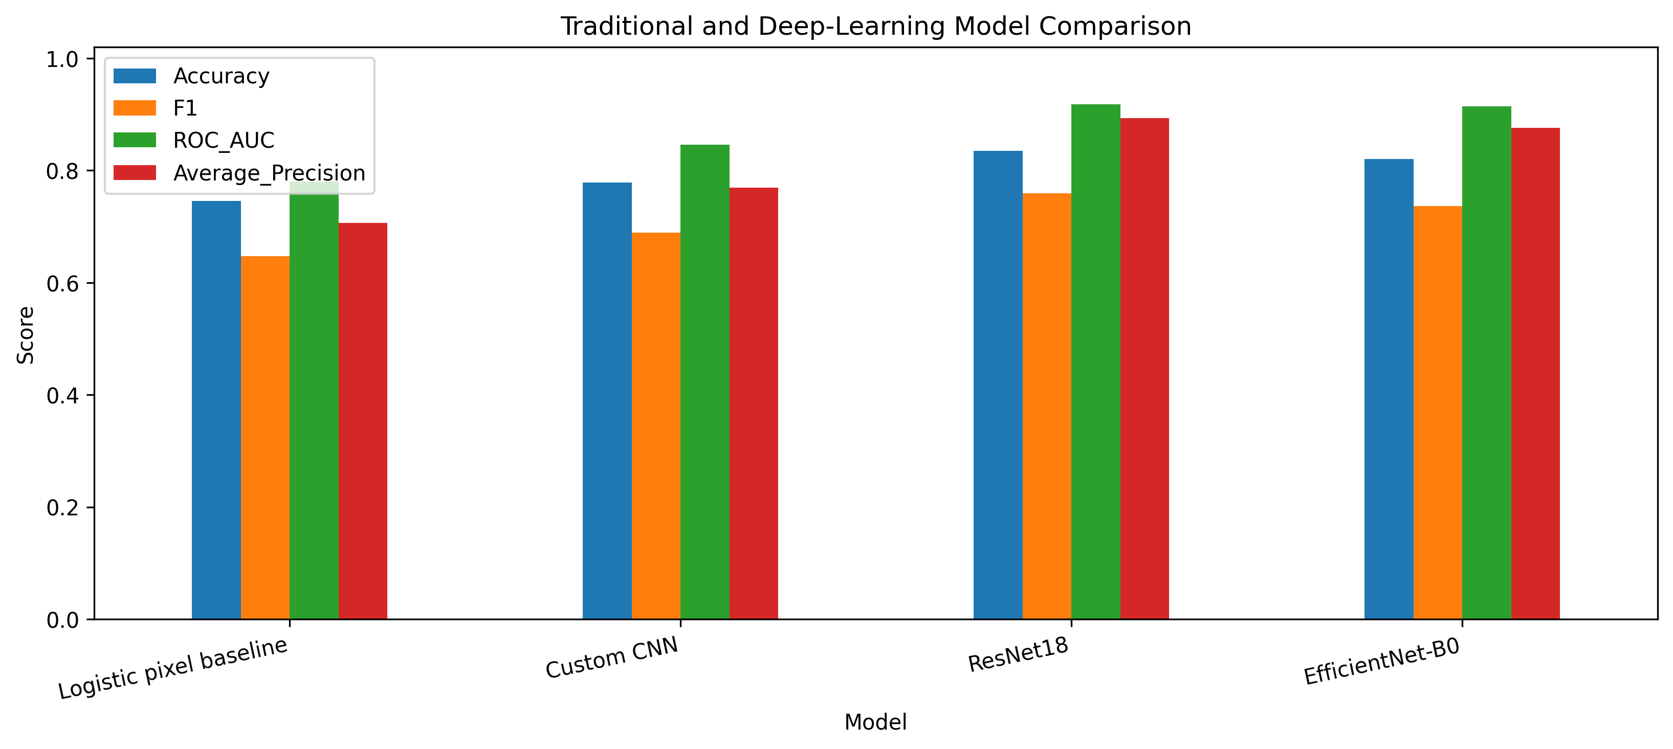
Figure 10. Held-out performance of the four classifiers at their validation-locked thresholds.
ResNet18 is the primary operational model because it has the highest observed accuracy, F1, balanced accuracy and ROC-AUC in the final comparison. EfficientNet-B0 remains close in ranking performance and is considerably smaller. The exact McNemar result for ResNet18 versus EfficientNet-B0 is non-significant, so the report does not claim statistical superiority. Model choice should therefore consider the observed error trade-off, uncertainty and resource profile, not a single rank ordering.

7.2 Confusion matrix and discrimination
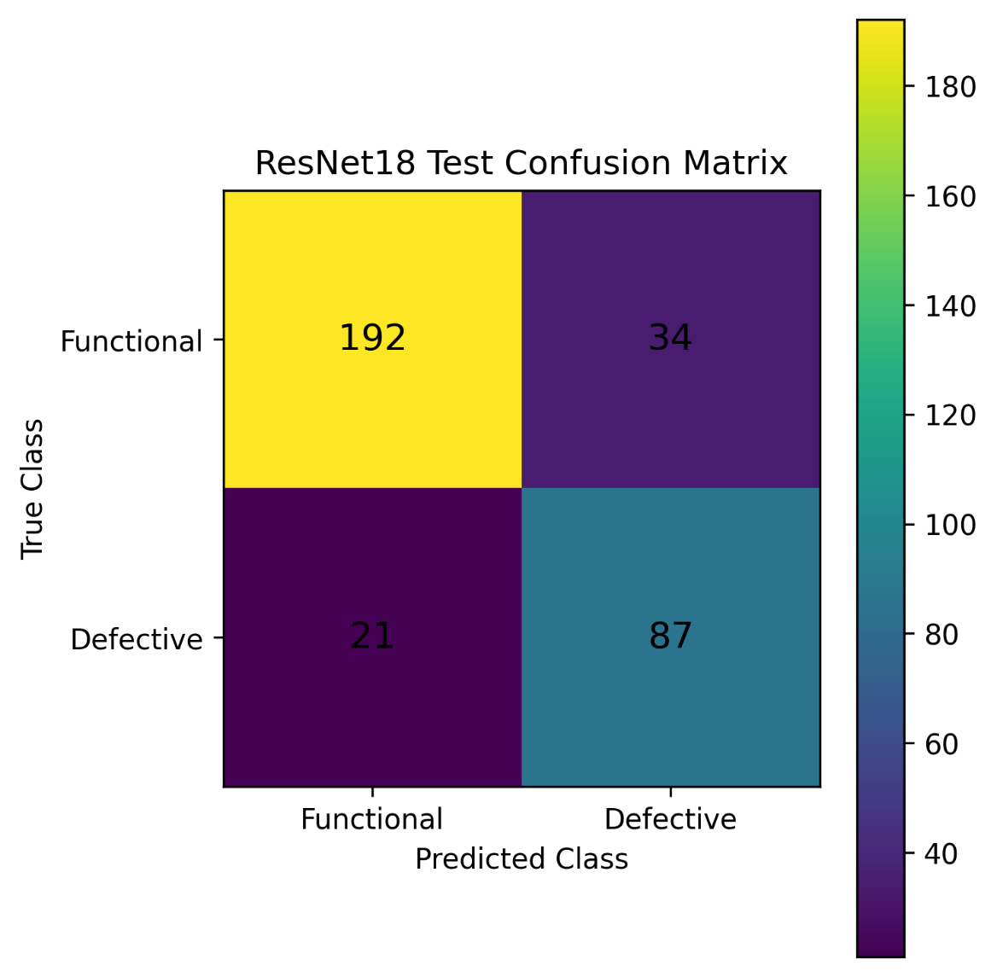
ResNet18 correctly classified 192 of 226 Functional cells and 87 of 108 Defective cells, producing 34 false positives and 21 false negatives. Its sensitivity was 0.8056 and specificity 0.8496 at threshold 0.2609. These 55 errors are still operationally material: a system used for triage would send some functional cells for unnecessary review and would fail to escalate some labelled defective cells. The model therefore supports research-stage prioritisation rather than autonomous inspection.Figure 10. ResNet18 confusion matrix on the 334-image held-out test set at validation-locked threshold 0.2609.
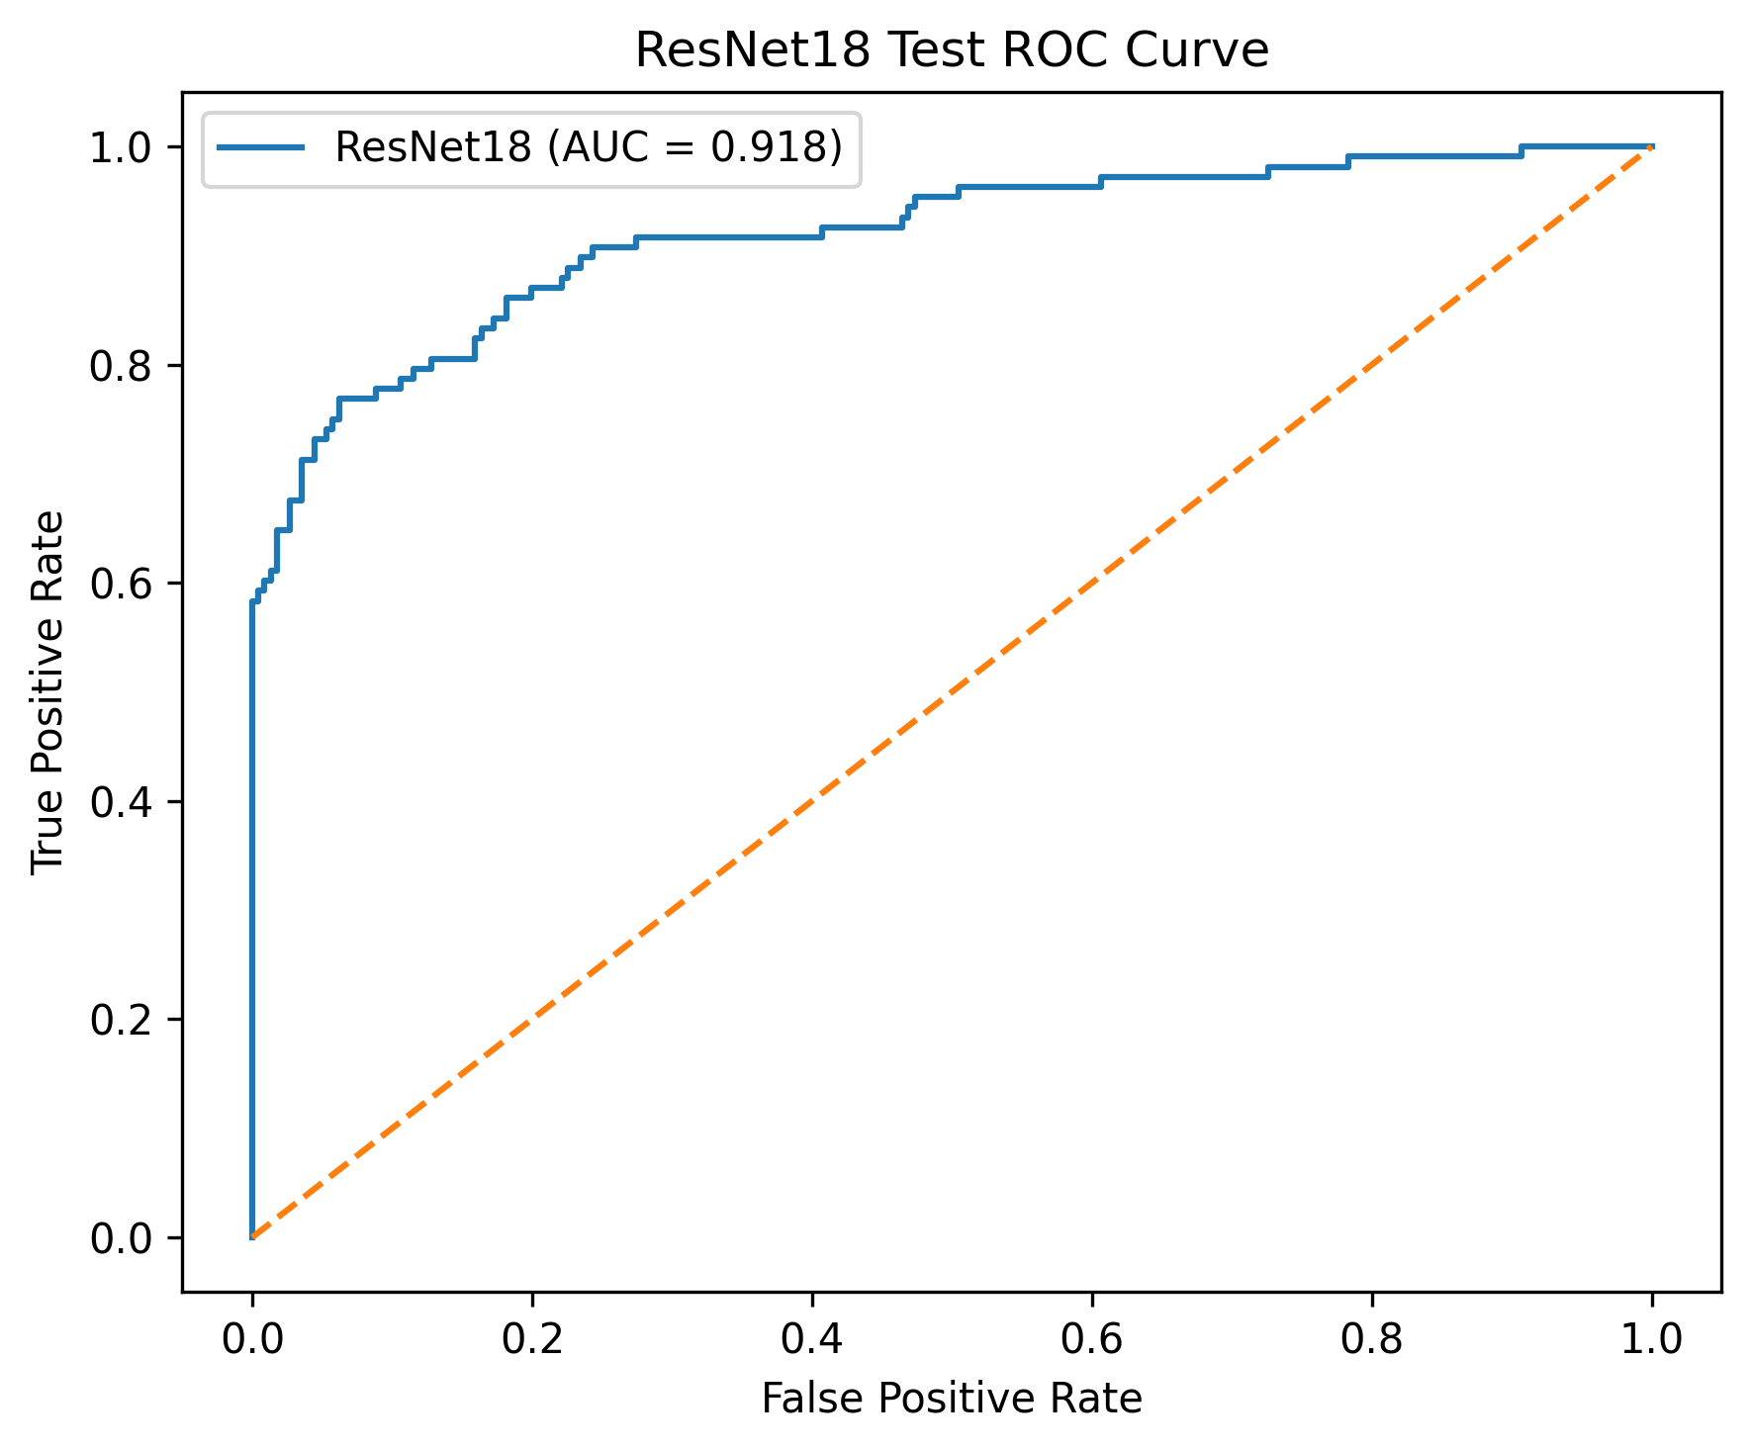
Figure 11. ResNet18 receiver-operating-characteristic curve; held-out ROC-AUC was 0.9182.
The precision–recall and ROC curves show useful score separation, but their smooth appearance should not hide the small minority-class count. Only 108 labelled defects occur in the test set. A movement of several cases can therefore change recall and F1 visibly. The operating threshold is a governance decision as much as a mathematical one. For example, lowering it generally recovers more defects but sends more Functional cells for review. The interface makes that tension concrete through counts rather than asking non-specialists to infer it from a curve.

7.3 Uncertainty and paired comparisons
Bootstrap resampling quantifies finite-test-set uncertainty around the ResNet18 point estimates. The 95% interval was 0.7934-0.8743 for accuracy, 0.6349-0.7982 for precision, 0.7252-0.8760 for recall, 0.6923-0.8167 for F1, 0.8807-0.9502 for ROC-AUC and 0.8486-0.9324 for average precision. These intervals do not include uncertainty from future manufacturers, modules, acquisition systems or annotation practices, so they should accompany rather than inflate the headline values.
Table 7. ResNet18 bootstrap uncertainty
Metric | Point estimate | 95% lower | 95% upper
Accuracy | 0.8353 | 0.7934 | 0.8743
Precision | 0.7190 | 0.6349 | 0.7982
Recall | 0.8056 | 0.7252 | 0.8760
F1 | 0.7598 | 0.6923 | 0.8167
ROC-AUC | 0.9182 | 0.8807 | 0.9502
Average precision | 0.8937 | 0.8486 | 0.9324

Exact McNemar tests produced p=0.0319 for Custom CNN versus ResNet18, p=0.1249 for Custom CNN versus EfficientNet-B0 and p=0.5114 for ResNet18 versus EfficientNet-B0. Only the first comparison crosses the 0.05 threshold. A non-significant paired difference is not proof that two models are equivalent; it indicates that this held-out sample does not establish a difference at the chosen level. The observed metric and efficiency trade-offs therefore remain relevant to model selection.

7.4 Error structure
The custom CNN made 74 errors, ResNet18 55 and EfficientNet-B0 60 on the same 334 test cases; the logistic baseline made 85. Prediction-level error tables preserve shared and model-specific hard cases for inspection. Images that challenge several architectures are particularly informative because they may reflect subtle visual evidence, annotation uncertainty or structures that are difficult for multiple representations. The report therefore keeps filenames and probabilities linked to diagnostic figures instead of reducing failure analysis to one aggregate number.
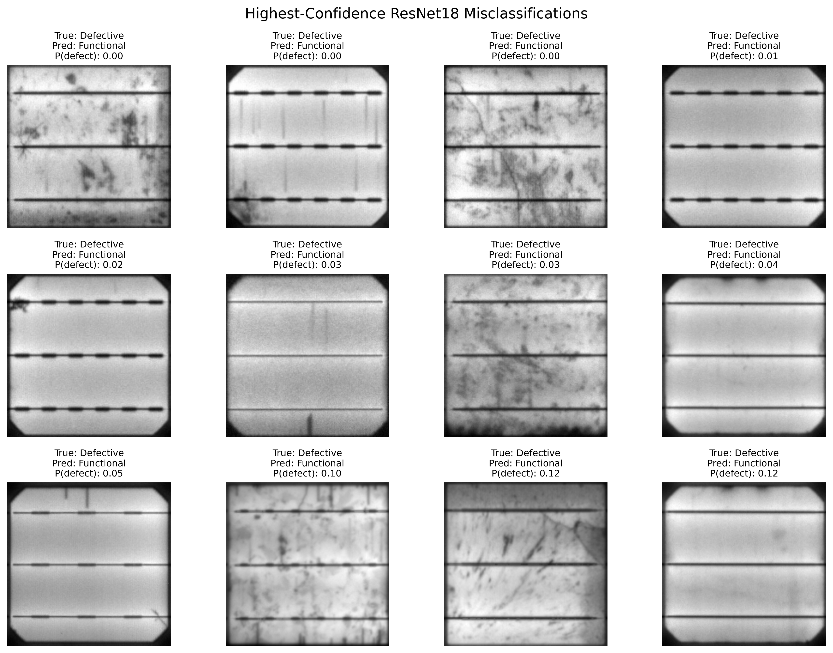
Figure 12. Representative ResNet18 false-positive and false-negative cases selected from stored test predictions.
Confidence separates many correct and incorrect predictions but is not a guarantee. ResNet18 mean confidence was 0.9367 for correct predictions and 0.6506 for incorrect predictions; median confidence was 0.9878 and 0.6907 respectively. Twenty of the 55 errors still had confidence at least 0.80. A future user interface should therefore avoid presenting a large probability as certainty and should provide calibrated wording, quality checks, abstention or human review for cases outside validated conditions.

7.5 Explainability and feature space
Grad-CAM was generated from ResNet18 layer4[-1].conv2 for true positives, true negatives, false positives and false negatives. The visualisations show which coarse spatial regions most influenced the selected output. Some maps focus on locally unusual areas, whereas others spread across cell texture or boundaries. This variety is informative because it discourages the assumption that the network implements a single defect detector. A plausible highlighted region can support investigation, but it cannot validate the physical nature of a defect without expert annotation and localisation ground truth.
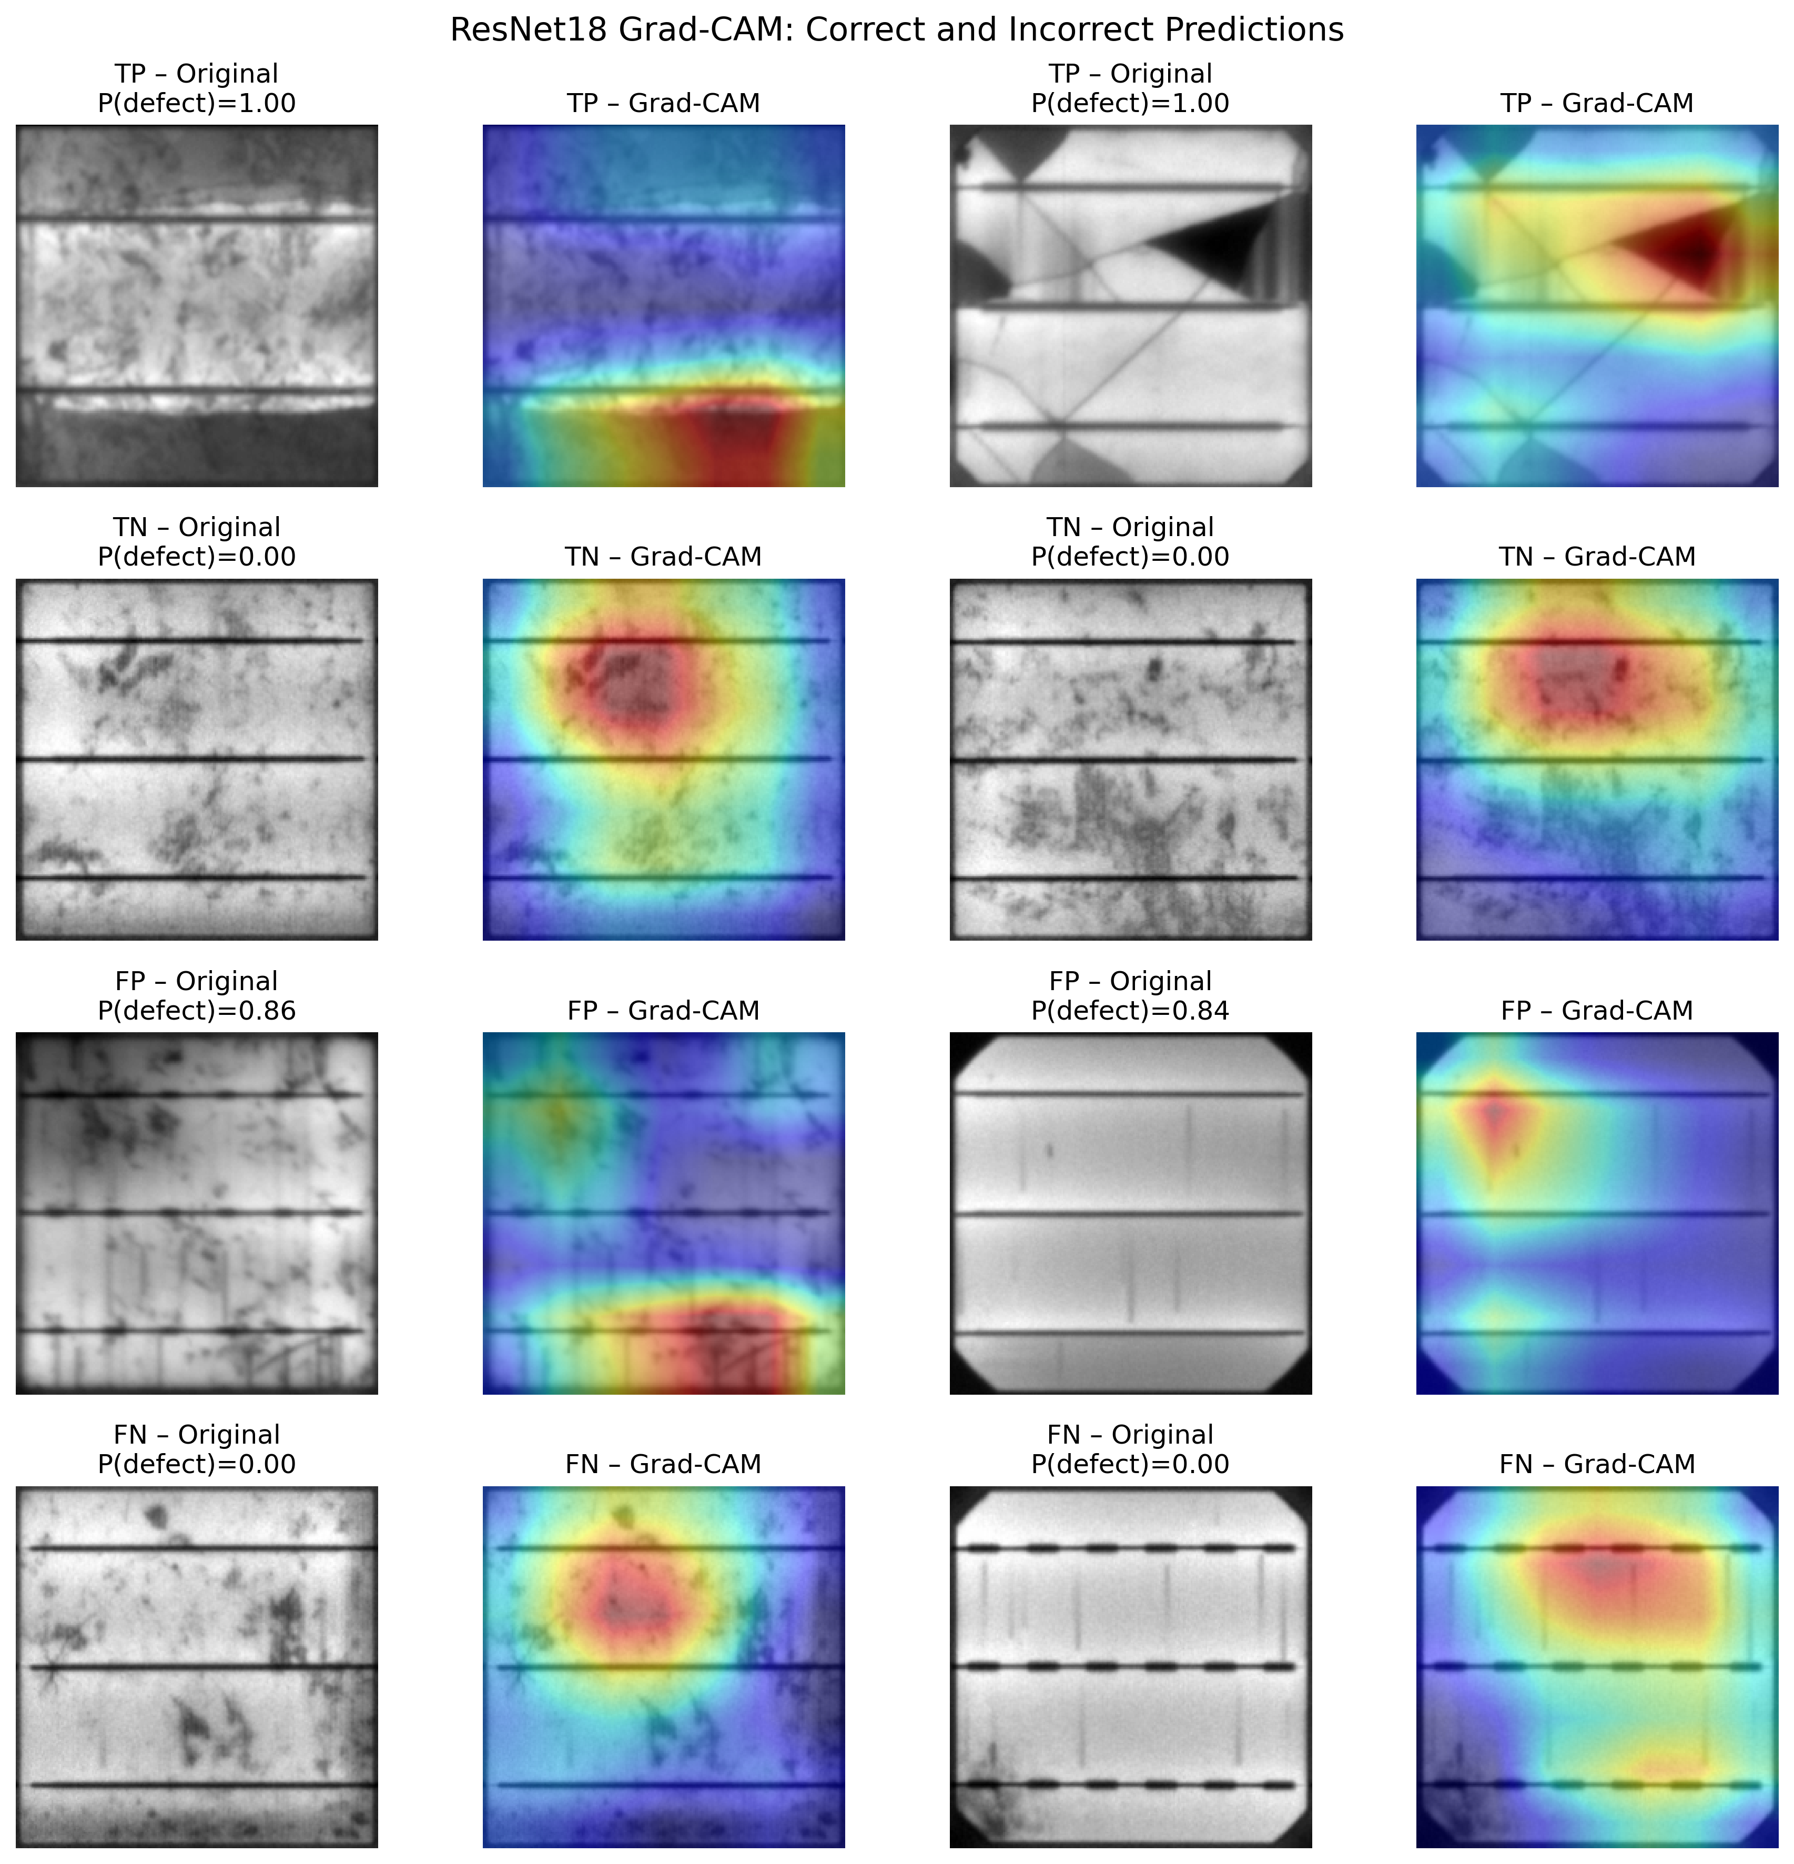
Figure 13. Grad-CAM examples across correct and incorrect ResNet18 decision categories; heatmaps indicate model sensitivity, not causal defect boundaries.
The final ResNet18 embedding is 512-dimensional. PCA found that the first two components explained 0.2631 and 0.1961 of variance, 0.4591 in total. PCA and t-SNE provide exploratory views of class structure and overlap, but neither is a measure of external validity. Apparent clusters depend on the representation and, for t-SNE, plotting hyperparameters; formal conclusions remain grounded in the locked predictions and prespecified metrics.
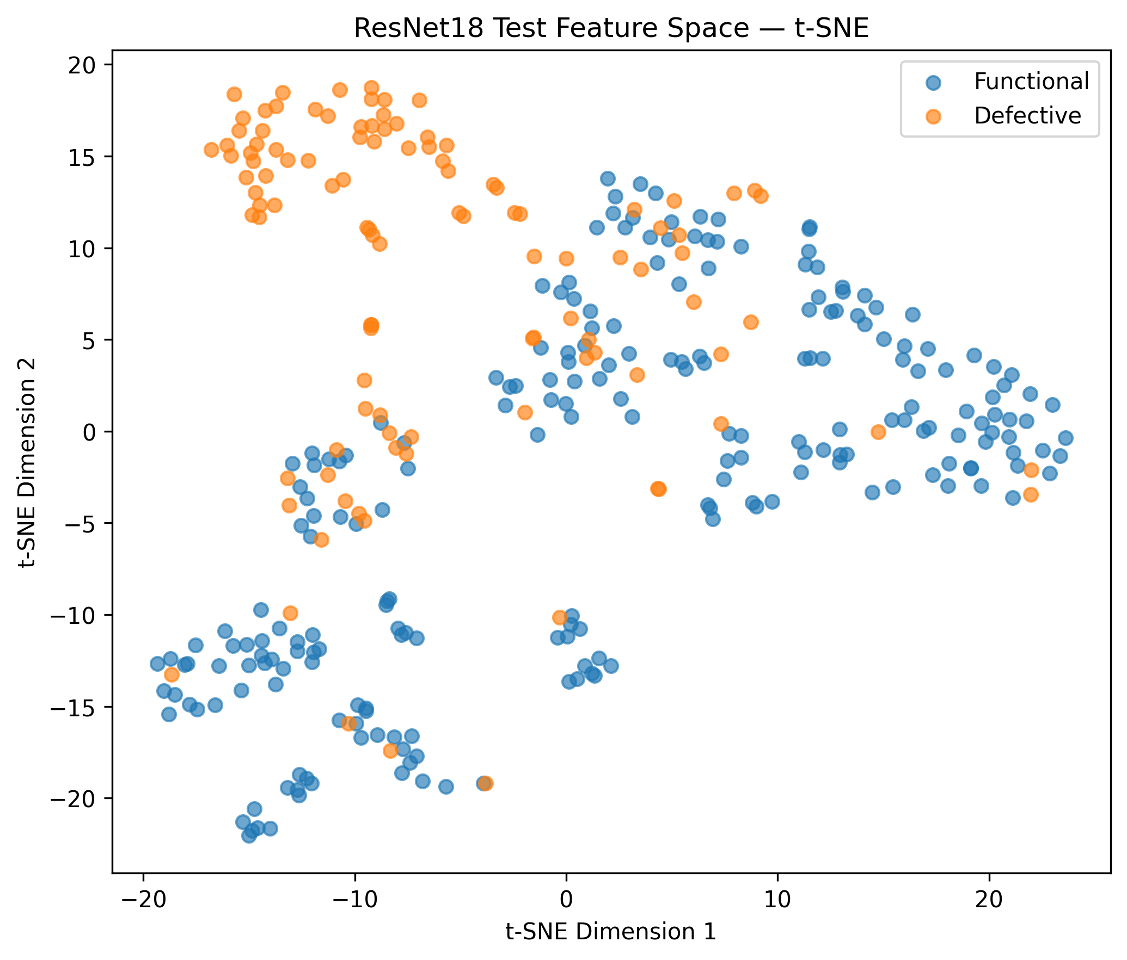
Figure 14. t-SNE projection of ResNet18 test embeddings, used as an exploratory view of local feature neighbourhoods.

7.6 Calibration
ResNet18 obtained a Brier score of 0.0944 and expected calibration error of 0.0542 on the held-out predictions. The reliability diagram shows that probability quality is improved but not perfect. If scores were used to support maintenance prioritisation or risk estimates, calibration would need to be fitted on appropriate validation data and checked again under the intended acquisition conditions. The current probabilities are useful model scores and uncertainty evidence, not universal physical defect probabilities.
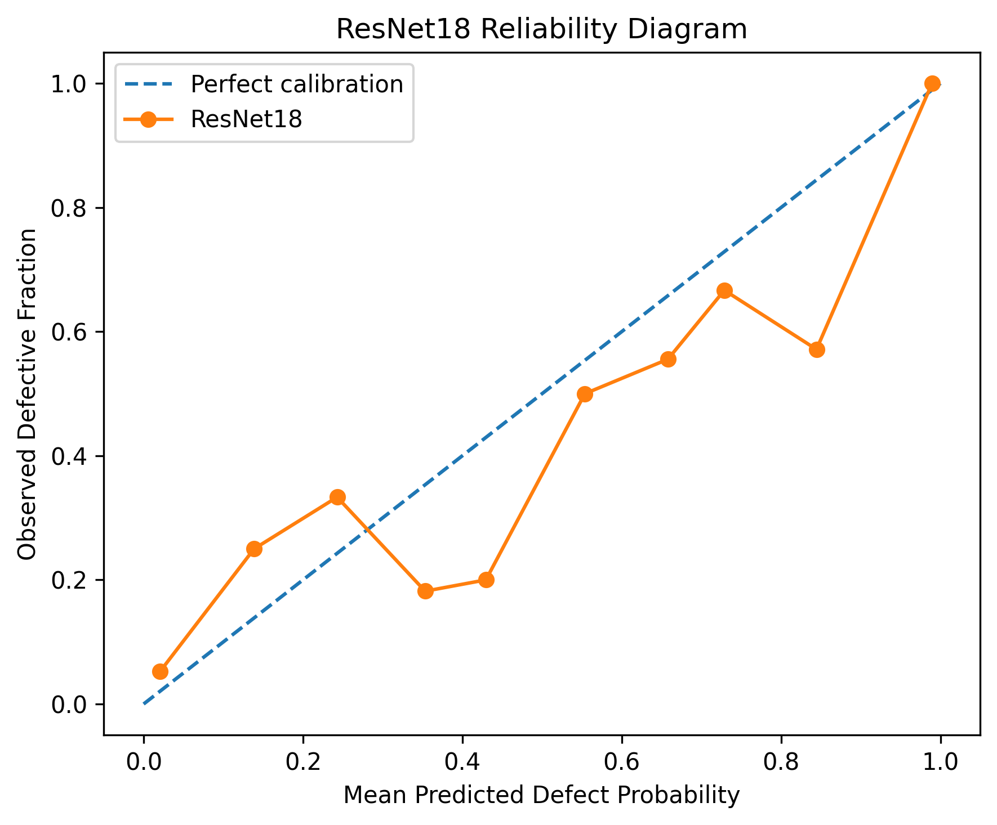
Figure 15. ResNet18 reliability diagram and calibration summary on the held-out test predictions.

7.7 Controlled robustness
Controlled perturbations revealed meaningful sensitivity. Relative to original accuracy 0.8353 and F1 0.7598, dark images produced accuracy 0.7186 and F1 0.6412; bright images 0.7216 and 0.6464; low contrast 0.8503 and 0.7748; blur 0.8204 and 0.7581; rotation 0.5000 and 0.5570; and Gaussian noise 0.8054 and 0.6012. Rotation caused the largest accuracy drop, while both rotation and noise materially changed the fixed-threshold decision behaviour. The experiment identifies sensitivity; it does not establish field robustness.
Table 8. Controlled perturbation results for ResNet18
Condition | Accuracy | Recall | F1 | ROC-AUC
Original | 0.8353 | 0.8056 | 0.7598 | 0.9182
Dark | 0.7186 | 0.7778 | 0.6412 | 0.8531
Bright | 0.7216 | 0.7870 | 0.6464 | 0.8401
Low contrast | 0.8503 | 0.7963 | 0.7748 | 0.9178
Blur | 0.8204 | 0.8704 | 0.7581 | 0.9166
Rotation | 0.5000 | 0.9722 | 0.5570 | 0.8803
Gaussian noise | 0.8054 | 0.4537 | 0.6012 | 0.8219

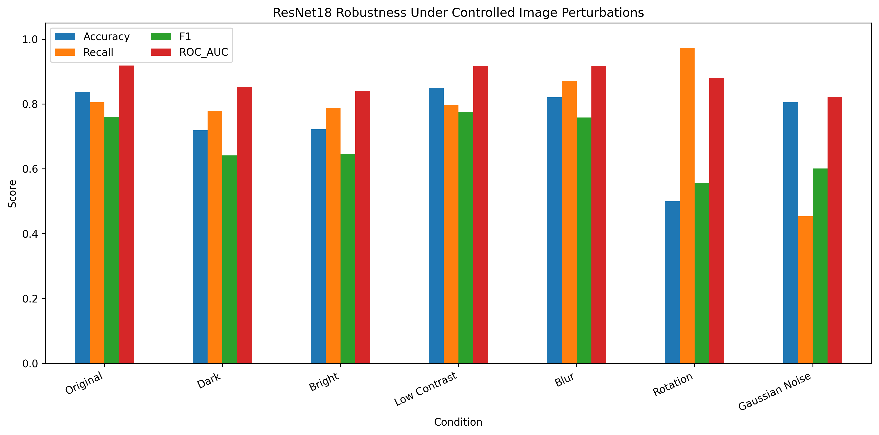
Figure 16. Change in ResNet18 performance under controlled brightness, contrast, blur, rotation and noise transformations.
The corruption results demonstrate that discrimination and threshold behaviour can fail in different ways. Rotation left ROC-AUC at 0.8803 while accuracy fell to 0.5000 because the score distribution shifted relative to the locked operating point. Gaussian noise lowered ROC-AUC to 0.8219 and recall to 0.4537, indicating degradation in both ranking and classification. A production pipeline would need controlled EL acquisition, image-quality validation, representative stress testing and carefully justified augmentation rather than assuming benchmark stability transfers automatically.

7.8 Cell-technology subgroup analysis
Monocrystalline test performance was accuracy 0.8593, precision 0.7800, recall 0.8298, specificity 0.8750, F1 0.8041 and ROC-AUC 0.9081 across 135 cells (77 TN, 11 FP, 8 FN, 39 TP). Polycrystalline performance was accuracy 0.8191, precision 0.6761, recall 0.7869, specificity 0.8333, F1 0.7273 and ROC-AUC 0.9222 across 199 cells (115 TN, 23 FP, 13 FN, 48 TP). The F1 gap is about 0.077; it remains operationally relevant but is smaller than in the previous implementation.
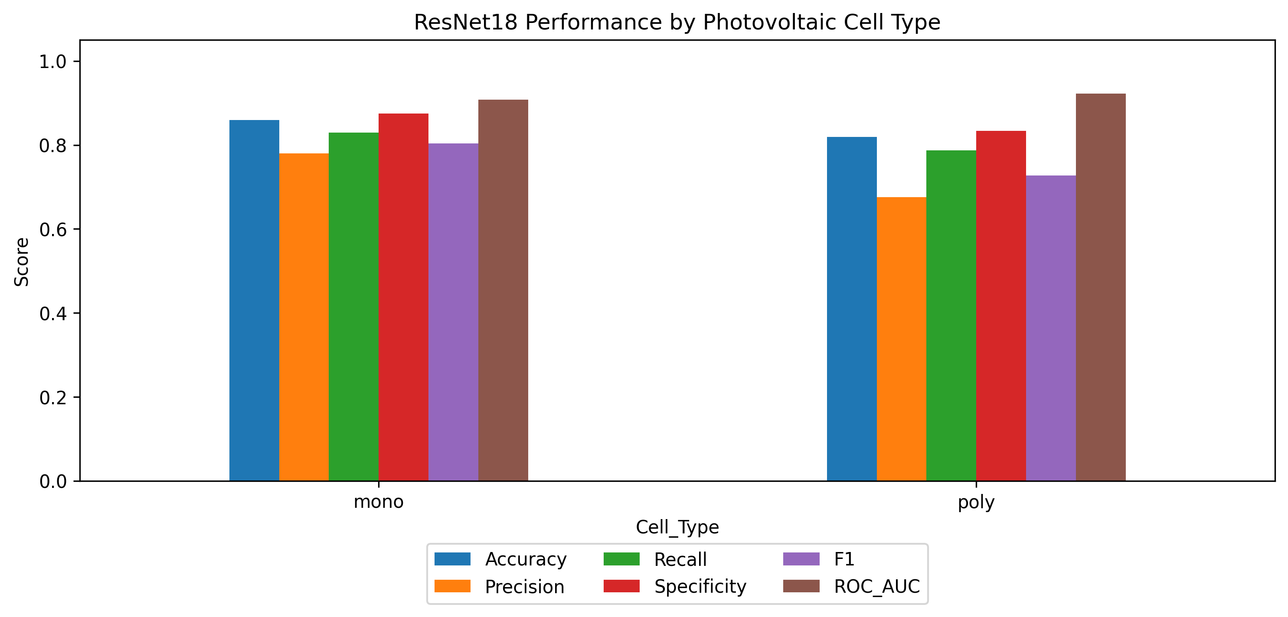
Figure 17. Exploratory ResNet18 performance comparison for mono- and polycrystalline test cells.
This analysis is not a fairness audit in the human-impact sense. Cell technology is a physical subgroup, sample sizes and class prevalence differ, and the dataset may not represent broader manufacturers. It is nevertheless operationally relevant because one threshold can behave differently across technologies. Future work should repeat the comparison with group-aware external modules, report confidence intervals within each technology, examine conditional calibration and test whether one model can support a common threshold without disproportionate false alarms.

7.9 Computational efficiency
Efficiency was measured for the three neural models in the reported CUDA environment. The custom CNN has 0.389 million parameters, a 1.50 MB checkpoint, about 0.941 ms/image latency and 1,485 images/s throughput. ResNet18 has 11.177 million parameters, a 42.71 MB checkpoint, about 2.327 ms/image and 1,159 images/s. EfficientNet-B0 has 4.009 million parameters, a 15.58 MB checkpoint, about 8.838 ms/image and 849 images/s. These measurements are runtime- and batching-specific; no particular GPU model is asserted by the supplied environment record.
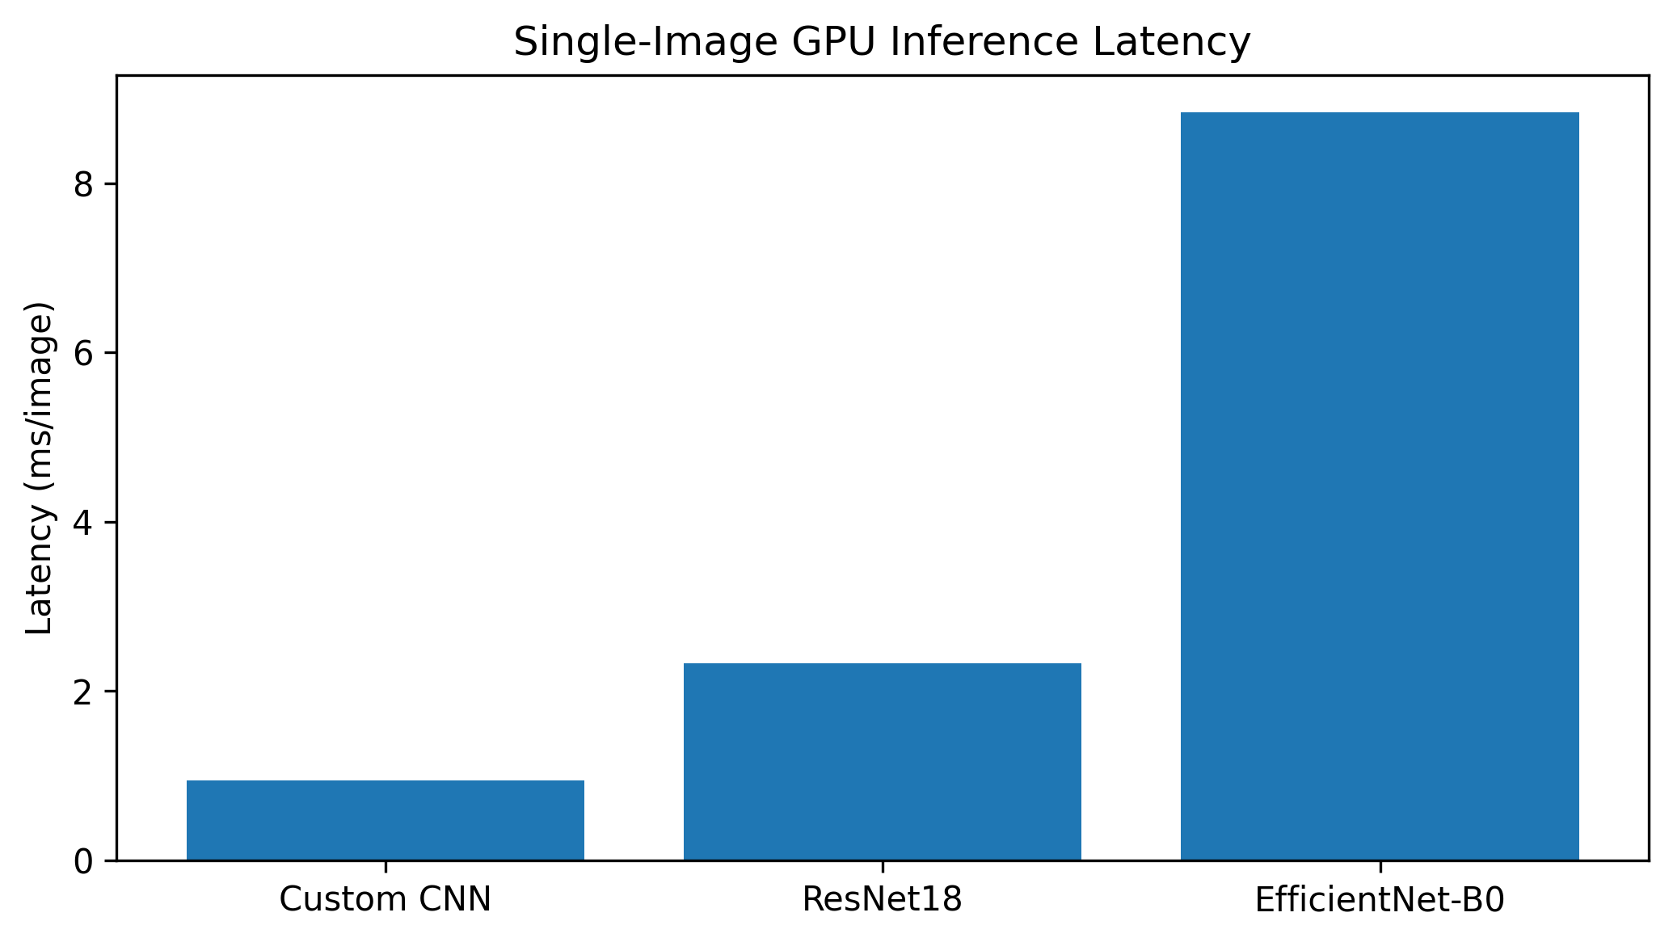
Figure 18. Measured per-image latency for the three neural models in the reported CUDA runtime.

8. Discussion

8.1 Answer to the research question
Within the selected high-confidence ELPV endpoint population, the answer is yes: image classifiers distinguish Functional from Defective cells substantially better than the traditional grayscale logistic baseline, and transfer learning gives the strongest overall evidence. ResNet18 achieved the best observed threshold-based and ranking metrics, with EfficientNet-B0 close behind. The result remains conditional on the controlled benchmark and does not establish physical defect localisation, power-loss prediction, manufacturer-independent transportability or autonomous industrial use.
The progression from logistic regression (F1 0.6473) to the custom CNN (0.6891), EfficientNet-B0 (0.7368) and ResNet18 (0.7598) makes the value of learned spatial representation explicit. ResNet18 gains accuracy and recall at the cost of substantially more parameters than the custom model, while EfficientNet-B0 offers a more compact transfer-learning alternative. Because ResNet18 versus EfficientNet-B0 was not significant by McNemar, architecture choice should remain linked to deployment constraints and prospective validation rather than a claim of universal superiority.

8.2 Operational meaning of errors
At the locked ResNet18 threshold, 34 of 226 labelled Functional cells would be escalated unnecessarily and 21 of 108 labelled Defective cells would not be escalated. Whether this trade-off is acceptable depends on the cost of missed defects, inspection capacity and the prevalence of defects in the intended workflow. Those requirements were not provided by the benchmark. A prospective pilot should therefore define an operating objective in advance and choose/calibrate the policy on independent validation data.
Confidence is insufficient for autonomous decision-making because 20 errors still exceeded 0.80 confidence. A safer interface should show the supported classes, model/version, quality status and appropriately calibrated score, then provide a clear review pathway. An abstention band could reduce forced decisions near uncertainty or out-of-distribution inputs, but its coverage and residual error require separate validation. The 401 ambiguous source labels provide a strong reason to design such behaviour rather than forcing every future cell into an endpoint class.

8.3 Strengths of the evidence
The re-implemented study has several methodological strengths: a pinned source revision, explicit target construction, frozen partitions, training-only augmentation, imbalance handling confined to fitting, a traditional baseline, validation-locked thresholds, complementary held-out metrics, prediction-level McNemar tests, bootstrap intervals, calibration, explainability, robustness, subgroup analysis, similarity verification and efficiency profiling. The new five-V, architecture/tool-selection, risk and governance artefacts also connect analytical choices to reproducible project evidence.
Negative evidence remains visible rather than being edited out: 55 ResNet18 errors, 20 high-confidence errors, rotation and noise failures, subgroup variation and strictly verified similar pairs are all reported. This is essential for responsible data-science practice. The feedback-integrated dashboard and optional prediction prototype are therefore communication aids around stored evidence, not mechanisms for converting an internal benchmark into an unvalidated deployed product.

8.4 Relationship to prior evidence
The observed ResNet18 accuracy is broadly consistent with the proposition in earlier EL literature that convolutional models can support automatic defect assessment, but direct numerical comparison would be unsafe. Deitsch et al. (2019) used a probability-oriented setting and different training details; other studies use other filters, class definitions, folds or augmentation. This project’s endpoint filtering, joint stratification and locked threshold define its own estimand. The responsible contribution is not a claim to a new state of the art; it is a complete, auditable implementation and a multi-dimensional evaluation that makes the limits of the benchmark visible.

8.5 Data-intuition value
The final evidence dashboard supports a concise demonstration of the implemented reasoning: compare the four classifiers, show bootstrap uncertainty and paired tests, inspect the locked ResNet18 confusion matrix, demonstrate robustness and subgroup variation, and connect those results to risk/governance actions. The optional probability-and-warning prototype can then illustrate how a future interface might expose model uncertainty without implying that the current study is a certified inspection service.

9. Ethics, privacy, security and risk management

9.1 Ethical use and communication
The central ethical risk is overclaiming. A high AUC on selected benchmark images may encourage users to treat the system as a certified defect detector. That would exceed the evidence and could produce missed maintenance, wasted inspection effort or misplaced trust. The report uses ‘proof of concept,’ names the excluded cases, reports false negatives and confidence failures, and distinguishes model attention from physical localisation. Any public demonstration should retain these statements. The model should complement, not replace, qualified engineering judgement until a formal validation and assurance process is completed.
Licensing is another ethical and legal obligation. The ELPV images and labels must be attributed under their applicable terms, and redistribution of a report package should not obscure original authorship. If the dashboard or model were adapted for commercial use, the team would need to confirm licence compatibility rather than assuming that a publicly downloadable dataset is unrestricted. Figures in this report were generated by the project from the supplied dataset and result artefacts; reference entries identify the source research.

9.2 Privacy and confidentiality
The current dataset includes no apparent personal identifiers, faces, locations or customer records. Privacy risk is therefore low for the research package. A deployed service could introduce new information: module serial numbers, facility identities, timestamps, geolocation, operator accounts or proprietary manufacturing images. Those data would require purpose limitation, access control, retention rules and an incident process. The offline dashboard is privacy-preserving by design because it loads embedded aggregate evidence and sends nothing to a server.

9.3 Security and integrity
Model integrity is the priority security concern. A swapped checkpoint, altered threshold or modified preprocessing mean can change predictions while leaving the interface visually unchanged. Versioned releases should bind code, model, configuration and threshold through a manifest and cryptographic hashes. Repositories should protect the main branch, require review for model-affecting changes and keep credentials outside notebooks. Untrusted uploaded images would need size, type and decoding limits to prevent denial of service or parser exploitation. Because the delivered explorer does not execute model code or accept uploads, its attack surface is intentionally small.

9.4 Risk register
Table 9. Updated project risk register
Risk | Likelihood | Impact | Implemented control | Residual action
Domain/acquisition shift | High | High | Controlled perturbations and explicit proof-of-concept scope | Independent multi-site/module validation
Missed defective cell | Medium | High | Recall/FN reporting, confidence analysis and human-review framing | Prospective cost-based operating policy
False-alarm overload | Medium | Medium | Precision, specificity and subgroup analysis | Pilot with review-capacity measure
Ambiguous source labels | High | Medium | Endpoint filtering; 401 cases explicitly excluded | Ordinal/probabilistic or abstention modelling
Cross-split dependence | Medium | High | MD5 + strict perceptual audit and sensitivity test | Module-grouped external split
Overconfidence | Medium | High | Calibration, 20 high-confidence errors reported, warning contract | Fresh calibration and human-factors tests
Artefact mismatch | Low | High | Pinned source, manifests, stored thresholds and model files | Release hashes and automated regression checks
Team evidence gap | Medium | Medium | Required-data templates retained | Insert authentic board, commit, review and contribution evidence

9.5 Contingency planning
If external validation falls below the agreed acceptance threshold, the contingency is not to adjust the external test set repeatedly. The team should diagnose acquisition differences, establish a new development cohort, revise preprocessing or training, and preserve a separate final confirmation set. If calibration is poor, outputs should be presented as relative scores until a valid calibration procedure is completed. If inference hardware cannot meet latency or memory constraints, the custom CNN, model quantisation or server-side triage can be evaluated, but each alternative requires fresh accuracy and robustness testing. If a release artefact fails its hash or input checks, inference should fail closed and refer cases to manual review.

10. Limitations and future work

10.1 Limitations
The main limitation is external validity. ELPV is a relatively small public benchmark, the primary analysis removes 401 ambiguous cases, and the available implementation does not guarantee module-level independence. The strict similarity audit found ten strong cross-split pairs, although removing affected test images left F1 unchanged at 0.7598. The study contains controlled perturbations but no independent manufacturer or acquisition cohort. Therefore the reported ROC-AUC 0.9182 and F1 0.7598 apply to the locked internal endpoint test, not arbitrary EL imagery.
A second limitation concerns failure severity and probability meaning. ResNet18 missed 21 of 108 labelled defective test cells and made 55 total mistakes; 20 mistakes still had confidence at least 0.80. Calibration is imperfect, mono/poly performance differs, and ELPV probabilities are annotation-derived. Grad-CAM does not establish physical defect location, embedding plots are descriptive, and efficiency figures are specific to the supplied CUDA runtime. These constraints prevent a deployment-readiness claim and motivate independent, group-aware external validation.

10.2 Prioritised future work
- Acquire an independently labelled, manufacturer-diverse EL cohort and preserve module-level groups across development and confirmation partitions.
- Model the intermediate defect probabilities rather than discarding them, comparing ordinal, regression, soft-label and abstention approaches.
- Define stakeholder error costs and prospective acceptance criteria before selecting an operational threshold; validate sensitivity, workload and calibration together.
- Standardise image acquisition and add input-quality checks for resolution, crop, intensity, noise and out-of-distribution structure.
- Evaluate calibration on a fresh calibration set and test whether subgroup-aware monitoring is needed without overfitting separate thresholds.
- Collect defect-localisation or defect-type ground truth if explanations are intended to support engineering diagnosis, then evaluate localisation quantitatively.
- Package model, preprocessing, threshold and schema in a versioned inference service with automated regression, security and rollback tests.
- Conduct a human-in-the-loop pilot measuring review time, override frequency, false-negative discovery and user interpretation of confidence and heatmaps.

10.3 Deployment readiness gates
A responsible transition would use explicit gates. Gate one is data validity: independent modules, documented labels and representative image quality. Gate two is analytical validity: predeclared metrics, confidence bounds, calibrated probabilities and no evidence of unacceptable subgroup failure. Gate three is operational fit: latency on target hardware, input validation, audit logs and a reviewed threshold tied to inspection capacity. Gate four is human factors: operators understand limitations and overrides. Gate five is governance: licensing, security, accountability, change control and rollback are documented. The present project completes a strong research prototype and evidence layer but does not pass all five deployment gates.

11. Technical assurance, demonstration and handover

11.1 Requirements traceability
Requirements traceability is now explicit across the package: source provenance and five-V audit support data governance; frozen split tables and similarity checks support leakage control; four-model comparison supports architecture justification; validation threshold records support test integrity; bootstrap/McNemar/calibration/robustness/subgroup analyses support critical evaluation; and the dashboard/prototype plus risk register support communication and responsible-use requirements. Authentic team-management evidence remains a separate submission responsibility.
Each headline can be traced to a persistent artefact. The 2,223-image binary population and 1,556/333/334 split are recorded in dataset and split summaries; the ResNet18 threshold 0.2609 is stored in validation/locked-threshold files; the 192/34/21/87 confusion counts reconstruct from test predictions; bootstrap intervals, calibration results, paired tests and similarity conclusions each have dedicated CSV evidence. This traceability reduces transcription risk and distinguishes implemented work from planned work. Before submission, local placeholders should be replaced with authentic accessible repository/project-board links.

11.2 Verification and test strategy
Regression checks should assert the pinned binary dataset size (2,223), held-out size (334), zero exact MD5 cross-split duplicates, ResNet18 threshold near 0.2609, confusion counts 192/34/21/87 for TN/FP/FN/TP, and F1 near 0.7598. Additional checks should verify that validation-selected threshold files match the model comparison and that figures are regenerated from the same prediction tables. These tests protect the report from silent mismatch after reruns or refactoring.
Regression testing should bind the final release. Expected checks can assert 2,223 binary images, 334 test images, ResNet18 threshold near 0.2609, confusion counts 192/34/21/87 (TN/FP/FN/TP), F1 near 0.7598 and zero exact MD5 cross-split duplicates. Threshold/model files should match the comparison CSV, and a deliberate retrain should create a new version rather than silently overwrite evidence. Numerical tolerances are appropriate because bitwise identity is not guaranteed across platforms.

11.3 Demonstration design
A concise demonstration can begin with the four-model design and explain why the logistic baseline was added, then show the validation-locked comparison and ResNet18 confusion matrix. It should next surface uncertainty, the strict similarity sensitivity result, high-confidence errors, Grad-CAM limitations, rotation/noise sensitivity and mono/poly subgroup behaviour. The final dashboard or optional prototype should be used to communicate evidence and safeguards rather than to imply live industrial deployment.
The demonstration should be rehearsed with an offline contingency. The HTML explorer is self-contained, but the team should keep a PDF or screenshot of its default state and the relevant CSV table in case a browser policy blocks local scripts. The model should not be retrained during the presentation; training time and stochastic variation distract from verified outcomes. If assessors ask for implementation evidence, presenters can open the relevant notebook cell, prediction table or checkpoint manifest. Each member should be able to explain one limitation and one design decision, not only the slide assigned to them.

11.4 Reproducible handover
A reproducible handover should contain the pinned-source information, executable notebook, environment specification, frozen splits, preprocessing configuration, three neural checkpoints, the logistic baseline joblib file, locked-threshold records, predictions, diagnostic tables, figures, risk/governance documentation and a file manifest. Release hashes should bind code, thresholds and models together. Team members should add authentic repository/project-board links and contribution evidence before submission.
Local absolute Windows paths found in raw prediction tables are a portability concern. They reveal a development directory and will not resolve on another system. Final repository versions should store relative image identifiers, while a configuration points to the local dataset root. The supplied browser explorer already avoids those paths by embedding only metrics and probability records. File sizes also require attention: Git Large File Storage or a release archive may be more appropriate for model checkpoints, with hashes recorded in the main repository. No original dataset images should be redistributed unless the licence and submission rules clearly permit it.

11.5 Monitoring and change control
If the prototype advances to a pilot, monitoring must focus on data and decision behaviour rather than server uptime alone. Input summaries should track dimensions, intensity distribution, blur, noise and the proportion rejected by quality checks. Prediction monitoring should track score distribution, positive rate, abstention rate and reviewer overrides by manufacturer and cell technology. Once delayed ground truth is available, sensitivity, specificity, precision and calibration can be calculated prospectively. Alert thresholds must be set from baseline variation. A shift alert should trigger investigation or suspension, not automatic retraining on unreviewed data.
Every model-affecting change needs a recorded reason, owner, evidence and approval. This includes a new training dataset, augmentation, architecture, normalisation, calibration method or decision threshold. Version numbers should appear in logs and the interface. A champion–challenger process can compare a proposed model prospectively while the approved champion continues to support review. Rollback must restore the complete bundle—checkpoint, preprocessing and threshold—because rolling back only the weights can create an incompatible system. These controls turn reproducibility from an academic convenience into operational accountability.

11.6 Sustainability and resource proportionality
Resource proportionality should be judged against the intended workflow. ResNet18 has about 28.7 times as many parameters as the custom CNN and is the best observed model, while EfficientNet-B0 reduces parameter count to about 4.0 million with only a modest F1 difference. Measured latency in the supplied CUDA runtime is approximately 0.94 ms/image for the custom CNN, 2.33 ms for ResNet18 and 8.84 ms for EfficientNet-B0. These results justify further device-specific profiling if edge deployment becomes a real requirement; they do not define production service latency.

11.7 Data-management lifecycle
The project should distinguish source, working and released data. Source images and original labels are immutable and retain their citation and licence record. Working data include cached tensors, temporary augmented batches and exploratory results; these can be recreated and should not be treated as ground truth. Released data include the frozen split identifiers, prediction tables and approved aggregate figures used by the report. A data dictionary should define every field, especially defect probability, binary label, cell type, predicted probability, thresholded class and correctness. Retention rules should remove redundant temporary copies while preserving the artefacts required to audit a published result.
Quality checks should be executable and versioned rather than recorded only in prose. A release-time validation can assert accepted image modes and dimensions, label domain, unique identifiers, split disjointness, exact class totals, finite probabilities and consistency between probability, threshold and predicted label. The same check should verify that each figure’s source table exists and that all required checkpoint hashes match. These controls are especially valuable after a teammate reorganises folders or reruns one notebook cell out of sequence. They convert assumptions into observable acceptance conditions.

11.8 Maintainability and code quality
The exploratory notebook documents the full experiment but a maintained system would separate reusable components for configuration, dataset loading, transforms, model construction, training, prediction and reporting. Parameters such as paths, seed, label filter, split ratio, normalisation and threshold should live in a configuration rather than be duplicated across cells. Functions should return data structures rather than depend on hidden global variables, and exception messages should identify the failed image or checkpoint. Unit tests can cover label mapping, channel replication, metric calculations and threshold behaviour with small synthetic arrays. This refactoring would not change the reported science; it would reduce accidental divergence when the project evolves.
Documentation should explain both the happy path and failure modes. A new user needs to know which cells require GPU access, how long training may take, which outputs can be regenerated from predictions, and what to do if the dataset is stored elsewhere. The model card should state intended use, excluded use, training population, evaluation metrics, uncertainty, subgroup observations, robustness limits and licence. A dataset card should describe filtering and splits. Together, these concise artefacts keep critical limitations close to the code instead of relying on a long report being read before every use.

11.9 Human factors and stakeholder evaluation
Stakeholder evaluation should test whether users understand the supported classes, the locked-threshold concept, confidence warnings, false-negative consequences and the distinction between Grad-CAM attention and verified defect location. The optional prediction prototype offers a concrete interface for such future testing, while the evidence dashboard supports reviewer understanding today. No user-study outcome is claimed in the current implementation.
Operational review should also measure workload. Reviewers can process a representative batch with and without model ordering, recording time, agreement, overrides and missed reference defects. The goal is not merely faster review; it is a safe improvement in the combined human–model system. If reviewers anchor on model output, blinded or counterbalanced study design may be required. A useful model that cannot be communicated without automation bias is not operationally successful. These human-factor questions sit outside the current benchmark but follow directly from its intended decision-support role.

11.10 Alternative explanations and falsification
A critical interpretation asks what else could produce the observed scores. The network may exploit global intensity, manufacturer-specific texture, crop alignment or cell-type composition correlated with labels. The robustness and Grad-CAM results provide clues but do not rule out those alternatives. Future experiments can mask borders and busbars, equalise intensity, evaluate across manufacturers, group by module and compare performance after physically motivated segmentation. If performance collapses while defect regions remain, the original model likely depended on nuisance structure. Designing tests that could falsify the preferred explanation is stronger than collecting only visual examples that appear supportive.
The model comparison itself could also be affected by optimisation choices. A custom CNN receiving additional tuning, pretraining or repeated seeds might narrow the gap. The current result is an implementation comparison under the recorded protocol, not an architecture theorem. Repeated training runs would estimate optimisation variability, while nested validation would reduce dependence on one split. Those experiments were not required to establish a functioning project, but they are important if small numerical differences become the basis of a publication or procurement decision.

12. Conclusion
The implemented project delivers a complete, ELPV analysis: pinned-source acquisition, endpoint target construction, frozen stratified splits, a traditional baseline plus three neural classifiers, validation-only thresholds, locked test evaluation, bootstrap uncertainty, paired comparisons, error/confidence analysis, Grad-CAM and representation plots, calibration, perturbation and cell-type analysis, similarity sensitivity, efficiency, governance documentation and a responsible prototype interface.
On 334 held-out endpoint images, ResNet18 achieved accuracy 0.8353, defective-cell recall 0.8056, specificity 0.8496, F1 0.7598 and ROC-AUC 0.9182 at threshold 0.2609. Its confusion matrix contained 192 true negatives, 34 false positives, 21 false negatives and 87 true positives. EfficientNet-B0 remained close, and the paired test did not establish a significant accuracy difference between the two transfer models. The logistic and custom baselines make the incremental benefit of transfer learning explicit.
The conclusion remains bounded by the strongest negative evidence. Rotation and Gaussian noise substantially degraded decision behaviour, 20 ResNet18 errors were high-confidence, mono/poly performance differed, and the benchmark does not supply independent external validation or guaranteed module-level grouping. Strictly verified similar pairs did not materially change F1 when affected test images were excluded, but this does not replace an external group-aware study. The model should therefore be treated as a research-stage triage aid and evaluation platform, not autonomous PV inspection or safety advice.

References
Akram, M. W., Li, G., Jin, Y., Chen, X., Zhu, C., Zhao, X., Khaliq, A., Faheem, M., & Ahmad, A. (2019). CNN based automatic detection of photovoltaic cell defects in electroluminescence images. Energy, 189, 116319. https://doi.org/10.1016/j.energy.2019.116319
Brier, G. W. (1950). Verification of forecasts expressed in terms of probability. Monthly Weather Review, 78(1), 1–3. https://doi.org/10.1175/1520-0493(1950)078%3C0001:VOFEIT%3E2.0.CO;2
Buerhop-Lutz, C., Deitsch, S., Maier, A., Gallwitz, F., Berger, S., Doll, B., Hauch, J., Camus, C., & Brabec, C. J. (2018). A benchmark for visual identification of defective solar cells in electroluminescence imagery. Proceedings of the 35th European Photovoltaic Solar Energy Conference and Exhibition, 1287–1289. https://doi.org/10.4229/35thEUPVSEC20182018-5CV.3.15
Deitsch, S., Christlein, V., Berger, S., Buerhop-Lutz, C., Maier, A., Gallwitz, F., & Riess, C. (2019). Automatic classification of defective photovoltaic module cells in electroluminescence images. Solar Energy, 185, 455–468. https://doi.org/10.1016/j.solener.2019.02.067
Guo, C., Pleiss, G., Sun, Y., & Weinberger, K. Q. (2017). On calibration of modern neural networks. Proceedings of the 34th International Conference on Machine Learning, 70, 1321–1330. https://proceedings.mlr.press/v70/guo17a.html
He, K., Zhang, X., Ren, S., & Sun, J. (2016). Deep residual learning for image recognition. Proceedings of the IEEE Conference on Computer Vision and Pattern Recognition, 770–778. https://openaccess.thecvf.com/content_cvpr_2016/html/He_Deep_Residual_Learning_CVPR_2016_paper.html
Hendrycks, D., & Dietterich, T. (2019). Benchmarking neural network robustness to common corruptions and perturbations. International Conference on Learning Representations. https://openreview.net/forum?id=HJz6tiCqYm
Krizhevsky, A., Sutskever, I., & Hinton, G. E. (2012). ImageNet classification with deep convolutional neural networks. Advances in Neural Information Processing Systems, 25. https://proceedings.neurips.cc/paper/2012/hash/c399862d3b9d6b76c8436e924a68c45b-Abstract.html
LeCun, Y., Bengio, Y., & Hinton, G. (2015). Deep learning. Nature, 521, 436–444. https://doi.org/10.1038/nature14539
McNemar, Q. (1947). Note on the sampling error of the difference between correlated proportions or percentages. Psychometrika, 12, 153–157. https://doi.org/10.1007/BF02295996
Paszke, A., Gross, S., Massa, F., Lerer, A., Bradbury, J., Chanan, G., Killeen, T., Lin, Z., Gimelshein, N., Antiga, L., et al. (2019). PyTorch: An imperative style, high-performance deep learning library. Advances in Neural Information Processing Systems, 32. https://proceedings.neurips.cc/paper/2019/hash/bdbca288fee7f92f2bfa9f7012727740-Abstract.html
PyTorch Contributors. (2026). Reproducibility. PyTorch documentation. https://docs.pytorch.org/docs/stable/notes/randomness.html
Selvaraju, R. R., Cogswell, M., Das, A., Vedantam, R., Parikh, D., & Batra, D. (2017). Grad-CAM: Visual explanations from deep networks via gradient-based localization. Proceedings of the IEEE International Conference on Computer Vision, 618–626. https://openaccess.thecvf.com/content_ICCV_2017/html/Selvaraju_Grad-CAM_Visual_Explanations_ICCV_2017_paper.html
Shorten, C., & Khoshgoftaar, T. M. (2019). A survey on image data augmentation for deep learning. Journal of Big Data, 6, 60. https://doi.org/10.1186/s40537-019-0197-0
Tan, M., & Le, Q. V. (2019). EfficientNet: Rethinking model scaling for convolutional neural networks. Proceedings of the 36th International Conference on Machine Learning, 97, 6105–6114. https://proceedings.mlr.press/v97/tan19a.html
van der Maaten, L., & Hinton, G. (2008). Visualizing data using t-SNE. Journal of Machine Learning Research, 9, 2579–2605. https://jmlr.org/papers/v9/vandermaaten08a.html

Appendix A. Individual work and contribution pages
Duplicate the following one-page template for every student. Replace all prompts with authentic evidence and keep each student’s page concise. These pages are intentionally incomplete because no member identities, Lab 1 screenshots, contribution records, or repository links were supplied.

A.1 Team member 1 – [INSERT NAME AND STUDENT ID]
Laboratory 1 evidence | [INSERT SCREENSHOT SHOWING LAB NAME, SCORE, COMPLETION STATUS, DATE AND TIME]
Project contribution | [DESCRIBE SPECIFIC TASKS, DECISIONS, TESTING AND DELIVERABLES]
Clickable evidence | [INSERT COMMIT / PULL REQUEST / ISSUE / NOTEBOOK / ARTEFACT LINKS]
Professional reflection | [WHAT WAS LEARNED, WHAT CHANGED, AND WHAT WOULD BE IMPROVED]

A.2 Team member 2 – [INSERT NAME AND STUDENT ID]
Laboratory 1 evidence | [INSERT SCREENSHOT SHOWING LAB NAME, SCORE, COMPLETION STATUS, DATE AND TIME]
Project contribution | [DESCRIBE SPECIFIC TASKS, DECISIONS, TESTING AND DELIVERABLES]
Clickable evidence | [INSERT COMMIT / PULL REQUEST / ISSUE / NOTEBOOK / ARTEFACT LINKS]
Professional reflection | [WHAT WAS LEARNED, WHAT CHANGED, AND WHAT WOULD BE IMPROVED]

A.3 Team member 3 – [INSERT NAME AND STUDENT ID]
Laboratory 1 evidence | [INSERT SCREENSHOT SHOWING LAB NAME, SCORE, COMPLETION STATUS, DATE AND TIME]
Project contribution | [DESCRIBE SPECIFIC TASKS, DECISIONS, TESTING AND DELIVERABLES]
Clickable evidence | [INSERT COMMIT / PULL REQUEST / ISSUE / NOTEBOOK / ARTEFACT LINKS]
Professional reflection | [WHAT WAS LEARNED, WHAT CHANGED, AND WHAT WOULD BE IMPROVED]

A.4 Team member 4 – [INSERT NAME AND STUDENT ID]
Laboratory 1 evidence | [INSERT SCREENSHOT SHOWING LAB NAME, SCORE, COMPLETION STATUS, DATE AND TIME]
Project contribution | [DESCRIBE SPECIFIC TASKS, DECISIONS, TESTING AND DELIVERABLES]
Clickable evidence | [INSERT COMMIT / PULL REQUEST / ISSUE / NOTEBOOK / ARTEFACT LINKS]
Professional reflection | [WHAT WAS LEARNED, WHAT CHANGED, AND WHAT WOULD BE IMPROVED]

A.5 Team member 5 – [INSERT NAME AND STUDENT ID]
Laboratory 1 evidence | [INSERT SCREENSHOT SHOWING LAB NAME, SCORE, COMPLETION STATUS, DATE AND TIME]
Project contribution | [DESCRIBE SPECIFIC TASKS, DECISIONS, TESTING AND DELIVERABLES]
Clickable evidence | [INSERT COMMIT / PULL REQUEST / ISSUE / NOTEBOOK / ARTEFACT LINKS]
Professional reflection | [WHAT WAS LEARNED, WHAT CHANGED, AND WHAT WOULD BE IMPROVED]

